AFSS CENTRAL EVALUATION SYSTEM
Central Assessment Team (CAT), HO Islamabad
1st Mid Term Examination 2017 – 18

COMPUTER - Class III
50 marks 2 hours

INFORMATION FOR STUDENTS
Marks are given against each question or part of question.
Write your name, roll number and date in the spaces provided below.
Student Name: | Roll No:
Center Name: | Date:
 | Day:
Invigilator Name: | Sign:
Marks Obtained: | Remarks:
Examiner Name:  Date: | Sign :  Day:

OBJECTIVE-20 marks

Q No1: Fill in the blanks. 5/
i) _______________ looks like a TV screen.
ii) You should not touch the ____________ when the computer is on.
iii) Printouts are also called _____________.
iv) __________ fixed inside the CPU box.
v) ____________ is the set of instructions that runs on the computer.
Q No2: Tick () the correct and cross () the wrong ones. 5/

i) Enter Key is the longest key as a keyboard. ________
ii) Listen carefully to your teacher. ________
iii) One can shout in the computer lab. ________
iv) F1, F2 ……. F12 are numbers keys. ________
v) MS. Paint and Ms. Word are software programs. ________
Q No3:Choose the correct option and write in the space provided. 5/

i) A ____________ is used to play games on the computer.
a) Joystick b) Scanner c) Printer
ii) A ___________ is a permanent memory.
a) RAM b) ROM c) MU
iii) ____________ is used to switch ON or switch OFF the computer.
a) Power button b) Open button c) Move button
iv) Always sit ___________ in your chair in-front of the computer.
a) straight b) bent c) lying
v) A __________ gives the results on paper.
a) Scanner b) Printer c) Monitor
Q No4: Arrange the following jumbled words with the help of picture clues.
5/
CUP | 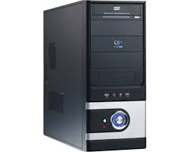
PINRETR | 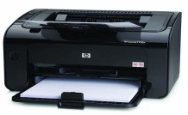
OUMES
YAKEROBD | 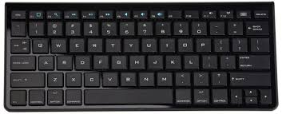
TROINOM | 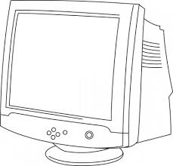

SUBJECTIVE-30 marks

Q No1: Write the full form of the following key terms. 10/
1) CPU ________________________________________________

2) VDU ________________________________________________

3) ALO ________________________________________________

4) CU _________________________________________________

5) MU _________________________________________________

6) RAM ________________________________________________

7) ROM ________________________________________________

8) Click ________________________________________________

9) UPS ________________________________________________

10) CD _________________________________________________

Q No2: Answer any five of the following questions. 5x4=20
1) What will happen if you sit too close to your monitor?
2) Why should you use the mouse properly?
3) What is meant by shutting down the computer?
4) What are the two types of computer memories?
5) What is the function of ALU?
6) Name some software programs?
7) Define computer.

