AFSS CENTRAL EVALUATION SYSTEM
Central Assessment Team (CAT), HO Islamabad
1st Mid Term Examination 2017 – 18

COMPUTER - Class IV
50 marks 2 hours

INFORMATION FOR STUDENTS
Marks are given against each question or part of question.
Write your name, roll number and date in the spaces provided below.
Student Name: | Roll No:
Center Name: | Date:
 | Day:
Invigilator Name: | Sign:
Marks Obtained: | Remarks:
Examiner Name:  Date: | Sign :  Day:

OBJECTIVE-20 marks

Q No1:Fill in the blanks. 5/

i) A computer is an ___________ machine.
ii) ___________ means to perform many activities at the same time.s
iii) ___________ is used to play games on a computer.
iv) ___________ is the brain of a computer.
v) _______________ is an output device.
Q No2: Match the following. 5/
Scanner | 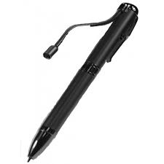
Touch Screen | 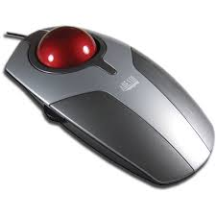
Speaker | 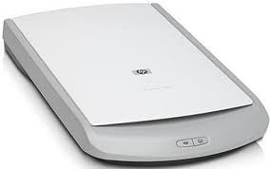
Trackball | 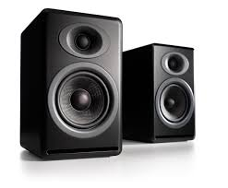
Light pen | 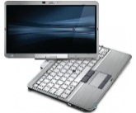

Q No3:Choose the correct option and write in the space provided below.
5/
i) The word ‘computer’ means to ___________.
a) category b) calculate c) common
ii) A computer works on the principle of _________cycle.
a) O- I-P b) I-P-O c) P-I-O
iii) __________ means to do some work without any error.
a) Versatility b) Accuracy c) Speed
iv) _________ is a sequence of black lines on white background.
a) Unicode b) Barcode c) Carcode
v) ________ is used to record sound into the computer.
a) Sanner b) Microphone c) Telephone
Q No4:True and False. 5/

i) ALU stands for arithmetic and long unit. ________
ii) Scanner is an output device. ________
iii) A computer cannot store a large amount of data. ________
iv) Accuracy and versatility are important features of the computer. ________
v) Speakers are used to hear the sound. ________

SUBJECTIVE-30 marks

Q No1: Answer any five of the following questions. 20/
1) What is scanner? Name two types of scanners.
2) Write down the names of different parts of CPU?
3) Mention any 4 uses of a computer?
4) What do you mean by accuracy of a computer?
5) Define any two of the following terms.
a) Input b) process c) Data d) Information
6) Write down at least 4 differences between a man and a computer.
7) Write down the characteristics of a computer.

Q No2:What do these key terms mean? 5/
a) VDU ____________________________________________

b) ALU ___________________________________________

c) CU ___________________________________________

d) MU ___________________________________________

h) DVD ___________________________________________

Q No3: Read the following clues and search 5 words in the grid given below. 5/

1) It is a pointing device ______________________.
2) It is the brain of the computer ___________________.
3) It is a sequence of black lines ___________________.
4) It reads and scans the text ___________________.
5) It is a storage device __________________.

M | O | N | I | T | O | R
O | P | O | J | Y | O | B
U | Q | M | K | G | S | A
S | C | A | N | N | E | R
E | R | S | O | M | A | C
G | O | T | O | U | L | O
G | S | E | C | P | U | D
S | E | R | D | S | H | E

