AFSS CENTRAL EVALUATION SYSTEM
Central Assessment Team (CAT), HO Islamabad
1st Mid Term Examination 2016 – 17/.

SCIENCE - Class II
50 marks 2 hours

INFORMATION FOR STUDENTS
Marks are given against each question or part of question.
Write your name, roll number and date in the spaces provided below.
Student Name: | Roll No:
Center Name: | Date:
 | Day:
Invigilator Name: | Sign:
Marks Obtained: | Remarks:
Examiner Name:  Date: | Sign :  Day:

OBJECTIVE-20

Q. No. 1: Fill in the blanks. 10
1) We have skin for the sensation of _____________.
2) __________ is developed for the persons who cannot see.
3) We can move and bend our bodies due to______________.
4) __________ have two antennae.
5) __________ are used as primary producer of silk.
6) Frogs and birds both lay __________.
7) I have two humps. I live in desert. Which animals am I? _________.
8) __________ have a pouch in their body.
9) In our body there are __________ bones.
10) Tongue helps us to __________.

Q. No. 2: Choose the correct answer. 5
1. Potatoes are rich in __________.
a) carbohydrates b) Proteins
2) __________ helps to fight against diseases.
a) fruits b) oils
3) __________ lives in forest only.
a) lion b) hen
4) A desert is typically an area that receives extremely __________ amount of rain
a) high b) low
5) Birds live in __________
a) Koop b) nest

Q. No. 3: Lable the life cycle of butterfly. 5

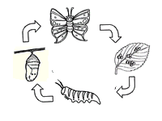

SUBJECTIVE-30

Q. No. 4: Write any two features of the following animals. 6
Insects __________ __________
Birds __________ __________
Fish __________ __________
Q. No. 5: Write down the names of the young animals. 4
Dog Lion Duck Cat
Q. No. 6: Look at the picture and write the correct option. 4
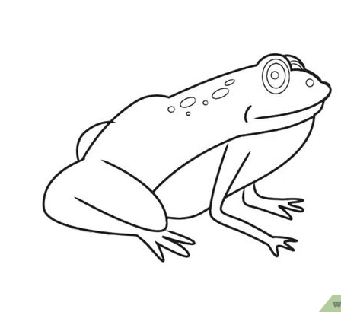
i) Frog __________ a tail.
a) has b) do not have
ii) It __________ a neck.
a) has b) do not have
iii) Its skin is:
a) dry b) wet
iv) It lives in ________
a) only water b) only land c) both land and water
Q. No. 7: Answer the following questions. 11
i) Write down about the 3R’s.
ii) Give three things that you should do to save environment.
iii) Write about some human activities that are causing damage to the environment.
iv) What is fertile soil?

Q. No. 8: Write about the function of the given parts of the eye. 5

