AFSS CENTRAL EVALUATION SYSTEM
Central Assessment Team (CAT), HO Islamabad
1st Mid Term Examination 2016 – 17

SCIENCE - Class VI
50 marks 2 hours

INFORMATION FOR STUDENTS
Marks are given against each question or part of question.
Write your name, roll number and date in the spaces provided below.
Student Name: | Roll No:
Center Name: | Date:
 | Day:
Invigilator Name: | Sign:
Marks Obtained: | Remarks:
Examiner Name:  Date: | Sign :  Day:

OBJECTIVE

Q. No. 1: Major body organs – label. 17

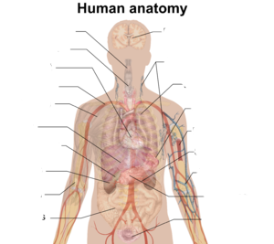

Q. No. 2: write down differences between plants and animal cells. 3
Feature | Animal Cell | Plant Cell
Cell wall
Chloroplast
Centriole

SUBJECTIVE

Q. No. 3: Make an eye and label it. 15

Q. No. 4: Answer the following questions. Any five 5 x 3 = 15
i) Why are kidneys important?
ii) What is the function of sclera?
iii) Define biotic and abiotic components with examples.
iv) What can you do to protect your environment?
v) What is the name of the biggest part of the human brain? Write down
its function.
vi) What is the role of decomposers?
vii) Define tissue name any two tissue of plants and animals.

