AFSS CENTRAL EVALUATION SYSTEM
Central Assessment Team (CAT), HO Islamabad
1st Mid Term Examination 2016 – 17

SCIENCE - Class VII
50 marks 2 hours

INFORMATION FOR STUDENTS
Marks are given against each question or part of question.
Write your name, roll number and date in the spaces provided below.
Student Name: | Roll No:
Center Name: | Date:
 | Day:
Invigilator Name: | Sign:
Marks Obtained: | Remarks:
Examiner Name:  Date: | Sign :  Day:

OBJECTIVE

Q. No. 1: Fill in the blanks. 10
i) Carnivore means ______________
ii) Plants get energy from the _______________ & use it to make food through __________________.
iii) In the _____________, food is squeezed down the tube.
iv) In the _____________ water is absorbed and created in faces and stool.
v) In the ___________, bile is stored.
vi) The rhythmic squeezing of the food through the digestive track is called _______________.
vii) Enzymes break down large protein into molecules such as __________.
viii) In the __________, nothing happens. Maybe the remaining part of our ancestors.
ix) Categories of nutrients that need to be digested are ___________.
x) Herbivores means _____________.

Q. No. 2: Label the digestive system. 10

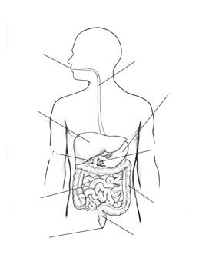

SUBJECTIVE

Q. No. 3: Answer the following questions. Any six 5 x 6 = 30
i) Write the difference between exhalation and inhalation.
ii) Diffentiate between diarrhea and constipation.
iii) How do animals interact in our ecosystem?
iv) How does energy more through a food web.
v) Describe two food chains in detail.
vi) Identify the factors that cause daily and yearly changes in a habitat.
vii) What are the three categories of food that don’t need to be digested.
viii) What is the relationship between predator and prey?

