AFSS CENTRAL EVALUATION SYSTEM
Central Assessment Team (CAT), HO Islamabad
1st Mid Term Examination 2016 – 17

SCIENCE - Class I
50 marks 2 hours

INFORMATION FOR STUDENTS
Marks are given against each question or part of question.
Write your name, roll number and date in the spaces provided below.
Student Name: | Roll No:
Center Name: | Date:
 | Day:
Invigilator Name: | Sign:
Marks Obtained: | Remarks:
Examiner Name:  Date: | Sign :  Day:

OBJECTIVE-20

Q No. 1:Label the parts of body. 10

Q. No. 2: Match the following. 5
 | Smell
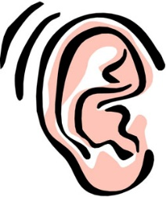 | See
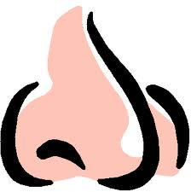 | Hear
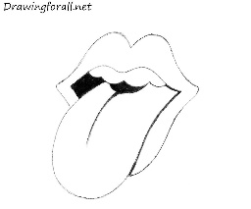 | Touch
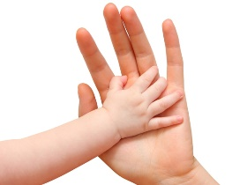 | Taste

Q. No. 3: Fill in the blanks. 5
i) Living things _________ by themselves.
ii) Rocks and stones are ____________ things.
iii) Living things need ______ , _______ and ____________.
SUBJECTIVE
Q. No. 4: Write 3 living and 3 non-living things. 6
Living things | Non Living thing

Q. No. 5: Write down 2 birds that cannot fly. 2

Q. No. 6: Write down 2 animals that live both on land & in water. 2

Q. No. 7: Write down 5 healthy habits of healthy people. 5

Q. No. 8: Circle 5 healthy foods. 5

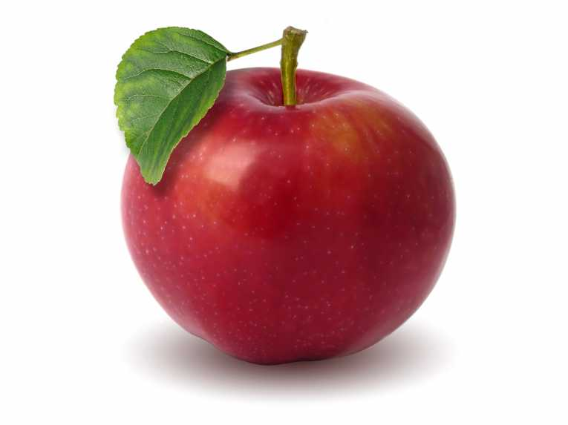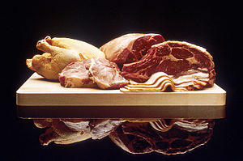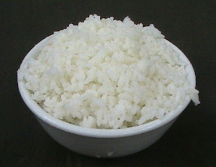

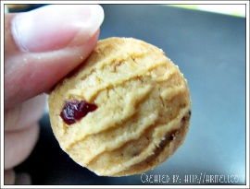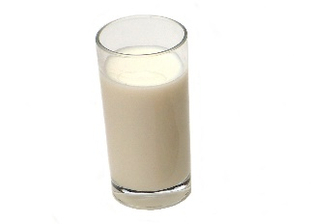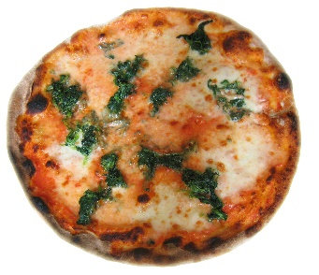

Q. No. 9: Write the items that belongs in the right column. 10

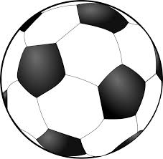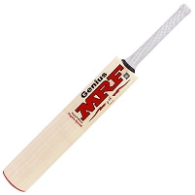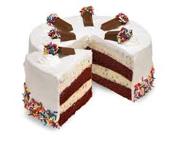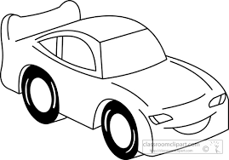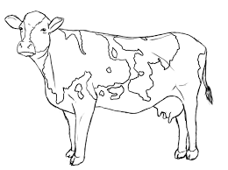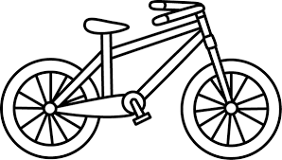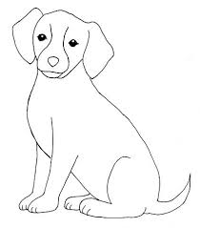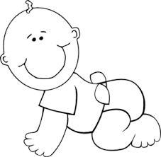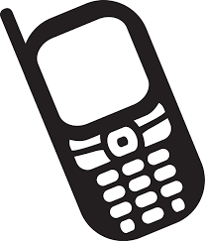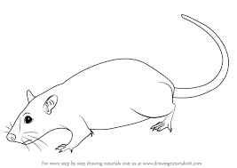

Living things | Non living things

