AFSS CENTRAL EVALUATION SYSTEM
Central Assessment Team (CAT), HO Islamabad
1st Mid Term Examination 2016 – 17

S. STUDIES - Class I
50 marks 2 hours

INFORMATION FOR STUDENTS
Marks are given against each question or part of question.
Write your name, roll number and date in the spaces provided below.
Student’s Name: | Roll No:
Center’s Name: | Date:
 | Day:
Invigilator’s Name: | Sign:
Marks Obtained: | Remarks:
Examiner’sName:  Date: | Sign :  Day:

OBJECTIVE
Q. No. 1: Write about your family. Fill in the blank. 10
i) My first name is _____________________.
ii) My family name is __________________.
iii) My fathers name is ______________________.
iv) My mothers name is ________________.
v) I have ____________brothers and ____________ sisters.
vi) Their names are ______________, ___________, __________, _________.
Q No. 2:Fill in the blanks according the pictures. 5
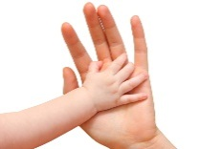
a):This is my ____________
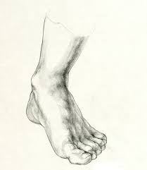
b):This is my___________
c):This is sara.
She has ______________ hair.
Her eyes are ______________.
d):This is Jim.
He has ______________hair.
His eyes are _________________.

Q. No. 3: Write the correct name under each picture. 5
Comb Soap Toothpaste
Nail clipper handkerchief
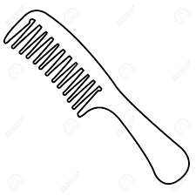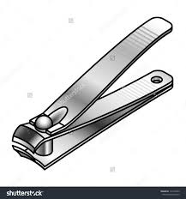
__________ __________ __________

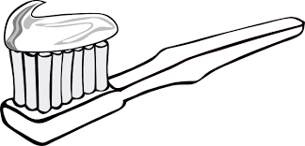

__________ __________

SUBJECTIVE-30

Answer any four of the following questions. 5 x 4 = 20
Q. No. 1: What parts of our body do you use for running?
Q. No. 2: What things do you do to keep clean?
Q. No. 3: What vegetables do you like the best?
Q. No. 4: What clothes do you wear in winter?
Q. No. 5: What clothes do you wear in summers?

Q. No. 6: Fill in the missing letters. 10
V __ ___ t Fr__c__ Jack__ __

Sk ___ ___ t Trou ___e____s S ___c___s

