AFSS CENTRAL EVALUATION SYSTEM
Central Assessment Team (CAT), HO Islamabad
1st Mid Term Examination 2016 – 17

MATHEMATICS - Class II
50 marks 2 hours
INFORMATION FOR STUDENTS
Marks are given against each question or part of question.
Write your name, roll number and date in the spaces provided below.
Student’s Name: | Roll No:
Center’s Name: | Date:
 | Day:
Invigilator’s Name: | Sign:
Marks Obtained: | Remarks:
Examiner’s Name:  Date: | Sign :  Day:

OBJECTIVE

Q. No. 1:a) Write the numbers that come “before”, “after” and “between”.
i) ____________ , 100
ii) 59 , ____________
iii) 67 , ____________ , 69
Write ‘>’ or ‘>’ in empty boxes.
iv) 809 790
v) 167 243
How many tens, how many ones? Count and write.

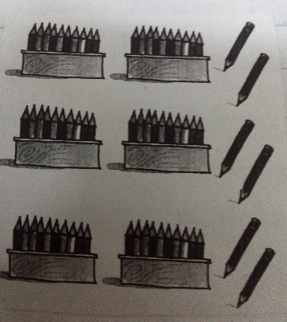 _______ Tens _____ ones
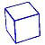
_________ hundreds _______ tens ______ ones

viii) Write in numbers.

5 tens and 3 ones = ___________________

Write in words.
ix) 8 tens and 4 ones = _______________
x) 10 + __________ = 90

Q. No 2(a): Complete the number pattern.

707 710 712

b) Put the following numbers in ascending order.

47, 6 , 54 , 8 , 23 , 98
______________________________

c) Put the following numbers in descending order.

98, 39, 69 , 93 , 99 , 92
______________________________
d) Write in hundreds, tens and ones. Then draw beads an abacus.

419 H T O

SUBJECTIVE – 30 Solve any three of the following question. Each question carry equal marks.
3*10=30 marks
Q. No. 1(a): Add the following

2 2
+ 3 9

b): Maha plants 25 trees. Aysha plants 8 more. How many trees do they plants altogether?

Q. No. 2(a): Subtract the following:

5 1
- 2 8

b): There are 64 cans of cola. The children drink 48 cans. How many are left?

Q. No. 3a: Write the number name:

333 ______________________________________________________

508 ______________________________________________________

b) Write in numbers.

i) Nine hundred and twenty four ___________________________

ii) Eight hundred and five ___________________________

Q. No.4(a): What number each abacus show? Write in box.

__________ __________

b) Draw beads on the abacus to show these numbers.

543

407

