AFSS CENTRAL EVALUATION SYSTEM
Central Assessment Team (CAT), HO Islamabad
1st Mid Term Examination 2016 – 17

MATHEMATICS - Class III
50 marks 2 hours
INFORMATION FOR STUDENTS
Marks are given against each question or part of question.
Write your name, roll number and date in the spaces provided below.
Student’s Name: | Roll No:
Center’s Name: | Date:
 | Day:
Invigilator’s Name: | Sign:
Marks Obtained: | Remarks:
Examiner’s Name:  Date: | Sign :  Day:

OBJECTIVE -20

Q. No1(a): Fill in the boxes with ‘>’ or ‘<’. 10
i) 990 ______________ 909
ii) 209 ______________ 216
iii) 9/10 ______________ 8/10
iv) 3/7 ______________ 5/7
Write in number.
v) Eight hundred and forty ______________
Write in words:

vi) 506: __________________________________________

Complete the following:

vii) 8/10 – 2/10 = ______________

viii) 3/5 + 1/5 = ______________

Write ‘+’ or ‘-‘ in the circle.

ix) 7/8 _____ 4/8 = 3/8

x) 2/5 _____ 2 / 5 = 4/5

Q. No. 2a: Circle the correct fraction according to picture. 5

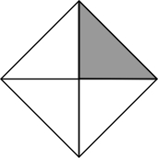
$\frac{1}{4} , \frac{1}{3} , \frac{1}{2}$

- Write the fraction of coloured part.

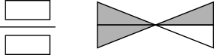
b) Colour the objects in each group to show the fraction.
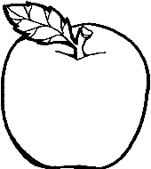
$\frac{2}{4}$

Q. No: 3a: Fill in the missing numbers. 5

2010 , 2013 , _____, 2019, ___________, ________, 2028

b) Write the predecessor or the successor of circled number? Write in box.

- 8119, 8120 = __________________

- 9998 , 9999 = ___________________

SUBJECTIVE - 30

Solve the following question. Each question carry equal marks. 3*10=30
Q. No1(a): Complete the following sums:
i)Add ii) Divide
3 6 2 9
+ 5 2 6 7 $7\sqrt{42}$

b): Sidra’s book has 200 pages. She has read 109 pages. How many more pages does sidra have to read to finish her book?
Q.No2(a): Solve the following :
i) 1/10 of 100kg

ii) ¼ of 280ml

b): Write the following fractions in ascending order.
$\frac{7}{8} , \frac{5}{8} , \frac{2}{8} , \frac{4}{8}$ __________________________
Write the following fractions in descending order.
$\frac{3}{8} , \frac{3}{10} , \frac{3}{4} , \frac{3}{6}$ __________________________
Q. No3(a): Write the value of the circled digits.
i) 4 3 3 3 ____________
ii) 3 4 8 0 ____________
b) Complete the equivalent fractions
i) $\frac{2}{3}=\frac{}{6}$ ii) $\frac{8}{10}=\frac{}{5}$
iii) add the following fraction
$\frac{4}{9}+\frac{1}{9}+\frac{2}{9}$ = ____________

