AFSS CENTRAL EVALUATION SYSTEM
Central Assessment Team (CAT), HO Islamabad
1st Mid Term Examination 2016 – 17

MATHEMATICS - Class I
50 marks 2 hours
INFORMATION FOR STUDENTS
Marks are given against each question or part of question.
Write your name, roll number and date in the spaces provided below.
Student’s Name: | Roll No:
Center’s Name: | Date:
 | Day:
Invigilator’s Name: | Sign:
Marks Obtained: | Remarks:
Examiner’s Name:  Date: | Sign :  Day:

OBJECTIVE

Q. No. 1:a) Fill in the Boxes with correct answer. 12
i) 2 + 8 =
ii) 10 - = 6
iii) 16 > 15 16 is __________ than 15.
iv) 2 < 19 2 is ______________ than 19.
v) Fill in the box with ‘<’ or ‘>’ 0 5
b) Write big, bigger and biggest.

_______ _________ _________
C) Begins with the biggest. Write 1 , 2 , 3 , 4.

_______ _______ ______ ______

Q. No. 2(a): Match each day to the correct number. 8 marks

Sunday 2nd
Tuesday 4th
Thursday 7th
Wednesday 1st
Monday 3rd
Friday 6th
Saturday 5th
b) Color the second, sixth and seventh rat.

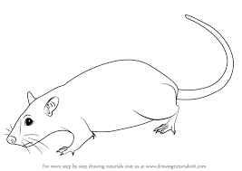

SUBJECTIVE – 30 marks

Solve the following question. Each question carry equal marks. 3*10=30marks
Q No1.(a): Add horizontally and then vertically.

11 + 5 =

5 + 11 =

Q No1.(b): T O T O
1 1 8
+ 1 8 + 0 1

Q. No2(a): Complete the missing word with ordinal numbers.
Monday is the ____________________
Tuesday is the ____________________
Wednesday is the ____________________
Thursday is the ____________________
Friday is the ____________________
Saturday is the ____________________
Sunday is the ____________________

Q No2.(b) Begin with smallest. Write 1, 2 , 3, 4.
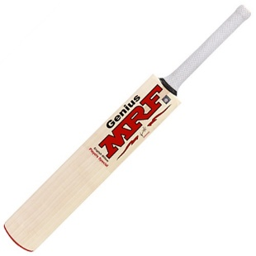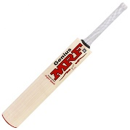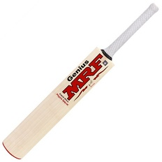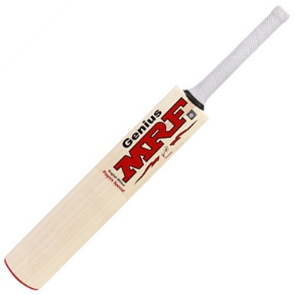
______ ______ ______ _______

Q. No3:(a) Subtract vertically and Horizontally.

i) 1 7 ii) 1 6

- 0 7 - 0 6

Q No 3(b): 13 - 0 =

5 - 5 =

