AFSS CENTRAL EVALUATION SYSTEM
Central Assessment Team (CAT), HO Islamabad
1st Mid Term Examination 2016 – 17

COMPUTER - Class II
50 marks 2 hours

INFORMATION FOR STUDENTS
Marks are given against each question or part of question.
Write your name, roll number and date in the spaces provided below.
Student Name: | Roll No:
Center Name: | Date:
 | Day:
Invigilator Name: | Sign:
Marks Obtained: | Remarks:
Examiner Name:  Date: | Sign :  Day:

OBJECTIVE

Q.1 Match the following 5
Monitor | 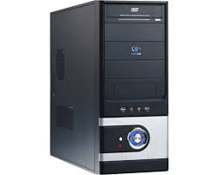
CPU
Mouse
Floppy Disk | 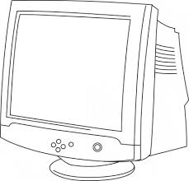
CD | 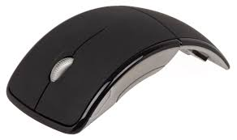

Q. 2: Fill in the blanks. 5

i) A computer does not make ________________.
ii) Computer is very ________________ in doing calculation.
iii) A _____________is a pointing device.
iv) __________ helps you listen to music.
v) A computer thinks with its ____________.
Q. 3: Circle the part of a computer that:
i) Help you type:
a) UPS b) Key board c) Mouse
ii) Helps you to draw:
a) Picture b) CPU c) Mouse
iii) Helps you to print:
a) Keyboard b) Printer c) Microphone

iv) Helps you record your voice:
a) Speaker b) Microphone c) UPS
v) Helps to keep the computer DN when there is no electricity:
a) CPU b) UPS c) Monitor
Q. 4: Fill in the missing letters. 5
i) M ___N ____ ______ OR looks like TV screen
ii) M ____ _____ SE is a pointing device.
iii) ___ P ___ keeps the computer on when electricity goes off.
iv) C ____ U thinks for the computer.
v) K ____ _____ BO ____R_____S. is used to type on the computer.

SUBJECTIVE

Q. 1: Name parts of a computer. 8
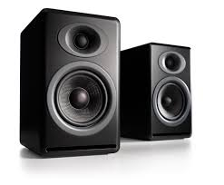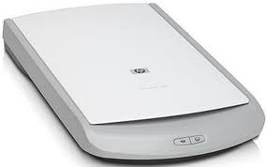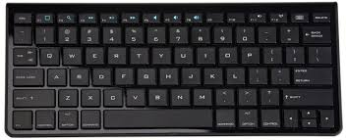
a. ____________________ b. ____________________
c. ____________________ d. ____________________
e. ____________________ f. ____________________
g. ____________________ h. ____________________
Q. 2: Define the following. 8
1) CPU 2) Keyboard 3) Printer 4) Head Phone

Q. 3: Answer the following questions. Any five 10
1) Name the device used to take printouts
2) What is a computer?
3) Write two differences between a computer and a human being.
4) Name two activities that you like to do the most on computers.
5) Which device thinks for the computer?
6) Name the pointing device which shows the arrow on the screen.

Q. 4: Arrange the jumbled words. 4
1) ALTPOP
2) DSTEKOP
3) PCOUMETR
4) PUC

