AFSS CENTRAL EVALUATION SYSTEM
Central Assessment Team (CAT), HO Islamabad
1st Mid Term Examination 2016 – 17

COMPUTER - Class IV
50 marks 2 hours

INFORMATION FOR STUDENTS
Marks are given against each question or part of question.
Write your name, roll number and date in the spaces provided below.
Student Name: | Roll No:
Center Name: | Date:
 | Day:
Invigilator Name: | Sign:
Marks Obtained: | Remarks:
Examiner Name:  Date: | Sign :  Day:

OBJECTIVE

Q. ۱: Fill in the blanks. 5

i) A computer is an ___________ machine.
ii) Data is raw ___________ or ___________.
iii) A computer cannot delete ___________ input given by user.
iv) __________ is the brain of a computer.
v) _______________ is a output device.
Q. 2: Match the following. 5
Scanner | 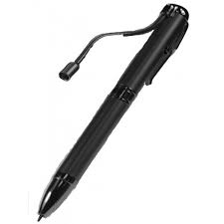
Touch Screen | 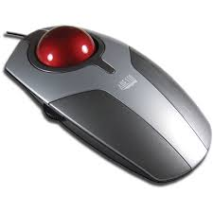
Speaker | 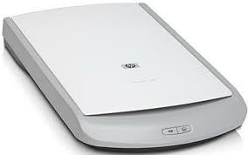
Trackball | 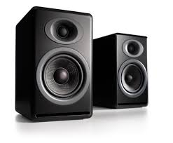
Light pen | 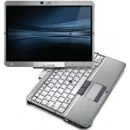

Q. 3: choose the correct option and write in the space provided. 5

i) The word ‘computer’ means to ___________.
a) category b) calculate c) common
ii) A computer works on the principle of _________cycle.
a) O- I-P b) I-P-O c) P-I-O
iii) __________ means to do some work without anyerror.
a) Versatility b) accuracy c) speed
iv) _________ is a sequence of black lines on white background.
a) unicode b) Bencode c) carcode
v) ________ is used to record sound into the computer.
a) scanner b) microphone c) telephone
Q. 4: True and False. 5

i) ALU stands for arithmetic long unit. __________
ii) Scanner is an output device. __________
iii) A computer cannot store a large amount of data. __________
iv) Computer converts in instructions into binary codes. __________
v) Data is processed information. __________

SUBJECTIVE

Q. 1: Answer any 6 questions. 24
1) What is a scanner? Name two types of scanners.
2) Write down the names of different parts of CPU?
3) Mention any 4 uses of a computer?
4) What do you mean by accnacy of a computer?
5) Define:
a) Input b) process c) Data d) Information
6) Write down at least 4 differences between a man and a computer.
7) Write down the characteristics of a computer.
8) What do these key terms mean?
a) CPU b) ALU c) CU
d) MU e) VDU f) LCD
g) CD h) DVD

Q. 2: Read the following clues and search 6 words in the grid given and across: 6

1) It is a pointing device __________________________
2) It is the brain of the computer ___________________
3) It is a sequence of black lines ___________________________
4) It reads and scans the text ___________________
5) It is a storage device ___________________
6) It looks like a TV screen ___________________
M | O | N | I | T | O | R
O | P | O | J | Y | O | B
U | Q | M | K | G | S | A
S | C | A | N | N | E | R
E | R | S | O | M | A | C
G | O | T | O | U | L | O
G | S | E | C | P | U | D
S | E | R | D | S | H | E

