AFSS CENTRAL EVALUATION SYSTEM
Central Assessment Team (CAT), HO Islamabad
Final Term/ Annual Examination 2016 – 2017

SCIENCE - Class II
100 marks 3 hours

INFORMATION FOR STUDENTS
Marks are given against each question or part of question.
Write your name, roll number and date in the spaces provided below.
Student Name: | Roll No:
Center Name: | Date:
 | Day:
Invigilator Name: | Sign:
Marks Obtained: | Remarks:
Examiner Name:  Date: | Sign :  Day:

OBJECTIVE-40 marks

Q No1:Fill in the blanks. 10
- _________________ is the closest planet to the sun.
- _________________appears blue due to methane gas.
- _________________is a dwarf planet.
- Plants produce oxygen through a process called _________________.
- _________________is a water world.
- Things with lots of heat energy are _________________.
- Sun is a _________________of light.
- _________________and light, both are types of energy.
- _________________is used to measure temperature.
- Granite is a _________________rock.
Q No2(a).Indicate whether the following statements are true or false. /5
i) Sun is an artificial source of energy.
ii) Earth completes its one rotation around its own axis in 365 days.
iii) Heat & Light are the types of energy.
iv) Fire does not give us light.
v) Neptune is known for its strong winds.

(b):Write the parts of the plants from where these food items come from.
5
Carrot Strawberry Sweet potato
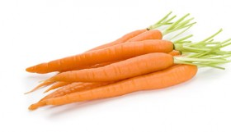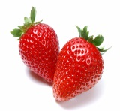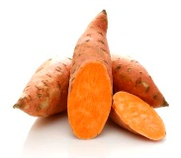

Egg plant Corn
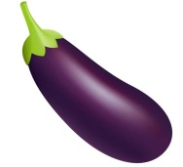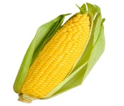

Q No3(a):Sort the following into conductors and insulators. /5
Copper,glass,aluminum,porcelain,platinum,plastic,rubber,gold,silver,wood

 | Conductors | Insulators
1.
2.
3.
4.
5.

(b):Write the following stones in the correct columns. /5
Hard stones | Soft stones
Chalk , Diamond, Coal, Marble, Graphite, Slate, sand stone, gran

Q No4:Fill in the blanks by choosing the correct answer. /10
- South pole of magnet will ____________________ south pole. Attract / repel
- ____________________is the organ that helps using hearing.
Eye / ear
- Magnets have ____________________magnetic field.
Visible / invisible
- Sound waves ____________________travel in space.
Cannot /can
- ____________________force produce magnetic field.
Magnetic / frictional
- Sun is a _____________ .
planet / star
- _____________between our shoes and floor stops us from slipping.
resistance /friction
- Area of magnetic force is called_______________.
Magnetic field /magnetic circle
- ________________is terribly hot.
Venus / Mars
10. ______________is known for its strong wind.
Neptune /Jupiter

SUBJECTIVE-60marks
Q No1:Write functions of the following parts of a plant. /10
a) Roots:________________________________________________________

_____________________________________________________________

b) stem:________________________________________________________

____________________________________________________________

c) flowers:_____________________________________________________

____________________________________________________________

d) fruit:________________________________________________________

____________________________________________________________

e) leaves: ______________________________________________________

_______________________________________________________
Q No2(i):Which factors are required for seed germination ? /2

ii): What is force of friction? /2
________________________________________________________________

_________________________________________________________________

iii): What effect is produced by the friction between wheel and breaks of a car? / 2

iv): Do you think life without sun is possible on Earth? Give reasons. /4

_____________________________________________________

_____________________________________________________

Q 3(i):Write the names of the planets in the solar system? /2

_____________________________________________________

ii):What is rotation? /2

_____________________________________________________
iii)What are the factors that make Earth a suitable place for life? /2
_____________________________________________________

iv)Write the names of natural and artificial sources of light in the columns given below. /4
Natural sources of light | Artifical sources of light
Q No4:Write any five uses of plants? /10
_______________________________________________________________

_______________________________________________________________

________________________________________________________________

________________________________________________________________

_________________________________________________________________

Q No5(a):Label the diagram. 5
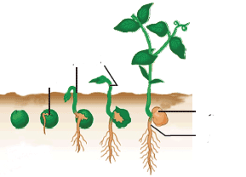
Germination of a Seed

b) Write the meanings of the following words. 5
Words | Meanings
Humidity
Rotation
Hibernation
Intensity
Orbit

Q 6:Write the uses of the following rocks. /10

 | Rocks | Uses
1- | coal
2- | chalk
3- | marble
4- | slate
5- | graphite

