AFSS CENTRAL EVALUATION SYSTEM
Central Assessment Team (CAT), HO Islamabad
Final Term/ Annual Examination 2016 – 2017

SCIENCE - Class III
100 marks 3 hours

INFORMATION FOR STUDENTS
Marks are given against each question or part of question.
Write your name, roll number and date in the spaces provided below.
Student Name: | Roll No:
Center Name: | Date:
 | Day:
Invigilator Name: | Sign:
Marks Obtained: | Remarks:
Examiner Name:  Date: | Sign :  Day:

OBJECTIVE-60marks

Q 1: Fill in the blanks. /10
- Anything that has mass and takes space is called ____________________.
- ____________________travels in straight line.
- Light takes ____________________minutes to reach the earth from the sun.
- Water boils at ____________________⁰C.
- ____________________does not have definite shape.
- Light can be ____________________from some surfaces like mirror or metals.
- ____________________is used to measure the temperature of air.
- ____________________is used to know the direction of wind.
- ____________________is used to measure the amount of rain.
- We should take some ____________________measure in extreme weather condition like thunderstorms.
Q 2. Write True or False. /10
- Mass depends on the size of the object . ________
- We apply brakes to speed up the car. ________
- Astronauts are weightless in space. _______
- Weight and mass are same. _________
- Rainbow at night is called Moon bow. _______
- Weight is measured in liters. ________
- Weight is zero where the force of gravity is zero. _______
- Spring balance is used to measure weight of an object. _______
- There is no water on the moon. _______
- Sundial is the device that tells the time of day by the position of the Sun. ________.

Q 3:Fill in the blanks by choosing the correct option. /10
- _________________ is when water vapour in the air gets cold and changes back into liquid.
- Condensation b. evaporation c. precipitation
ii) Extreme pressure and heat over time forms ______________ rocks.
- Metamorphic b. igneous c. sedimentary
iii) Which of the following is the igneous rock:
a. Marble b. Slate c. Granite
iv) When magma cools and solidifies it forms _________________.
a. Igneous rock b. Metamorphic rock c. Sedimentary rock D. All of these
v) _________________is artificial source of light.
a. Heater b. Sun c. Firefly
vi) The main function of ___________is to anchor plant.
a. stem b. root c .leaves
vii) The moon _________________its own light.
a. Gives b. does not give
viii) _____________ is the force with which earth attracts bodies near its surface.
- Motion b. gravity c. resistance
ix) ___________ are called food factories of the plants
a. roots b. leaves c. shoots
x)The ability of a material to stretch in different directions is called
________________.

Q No2:Match the columns. 10
New Moon
Waxing Crescent | 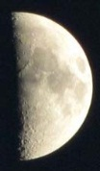
First Quarter | 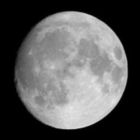
Waxing Gibbous | 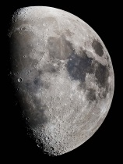
Full Moon | 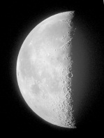
Waning Gibbous | 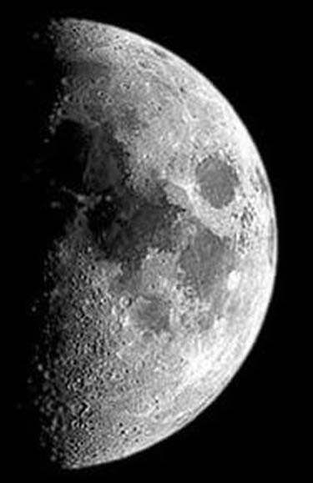
Last Quarter | 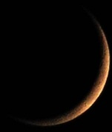
Waning Crescent | 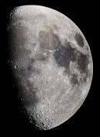

SUBJECTIVE-60marks
Q No1:Attempt any eight of the given questions. Each question carries equal marks. 2x8=16
- Write any two uses of hemp fiber?
- Name some magnetic materials?
- What is the other common name of Indian pipes?
- What is the speed of light?
- How plants help in lowering temperature of the surroundings?
- Which material gets attracted by magnet?
- What is transpiration?
- Define insulator? Give two examples.
- Why photosynthesis is important for plants?
- How can mass be measured?
- What are conductors? Give two examples.
- What are alloys?
- Which property of matter makes it withstand more weight?
- Give two examples of each: natural and artificial sources of light.
(b): label the water cycle. 4

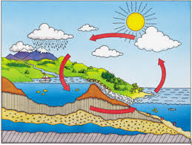

Q.2. Answer any five of the given questions in detail. 6x5= 30
- Draw and label water cycle?
- Why morning and evening temperature is less as compared to the afternoon.
- Write the uses of the following instruments.
- Rain gauge , b) thermometer ,c) wind wane , d)sundial ,e)spring balance.
- What is force of friction? State three ways to reduce friction.
- What is solar energy? Write any two uses of solar energy.
- Write any five uses of plants.
- How are shadows formed?
- Differentiate between condensation and boiling?
- Differentiate between elasticity and flexibility?
- Define matter and its properties ?
- Briefly define different states of matter.

Q 3:Name the materials under following columns. 5
Solids | Liquids | Gas

Q No4:Write the meanings of the following words 5
Words | Meanings
Fibrous root
Photosynthesis
Mass
Gravity
Chlorophyll

