AFSS CENTRAL EVALUATION SYSTEM
Central Assessment Team (CAT), HO Islamabad
Final Term/ Annual Examination 2016 – 2017

SCIENCE - Class VI
100 marks 3 hours

INFORMATION FOR STUDENTS
Marks are given against each question or part of question.
Write your name, roll number and date in the spaces provided below.
Student Name: | Roll No:
Center Name: | Date:
 | Day:
Invigilator Name: | Sign:
Marks Obtained: | Remarks:
Examiner Name:  Date: | Sign :  Day:

OBJECTIVE-40 marks

Q No1:Fill in the blanks. 10
- Anything that has ____________ and occupies space is called matter.
- The _________________of an object in independent of the objects location in space.
- All ____________are on the periodic table.
- Most non-metals are ______________ at room temperature.
- Materials that does not allow electricity to pass through are called ___________________.
- Concave mirrors are ______________inward.
- Light travels in ________________lines.
- Acquired energy is known as ______________________ energy.
- _____________________of an atom is the source of nuclear energy.
- A _______________ is a wheel that has a rope wrapped around it.
Q No2:Choose the correct answer. /6
- What type of surface reflect light well?
a) Light coloured and smooth b) Dull and dark
c) dark coloured and smooth
- How do mirrors work?
a) By reflecting the light that hits them b) by absorbing the light that hits them
c) By letting through the light that hits them
- A material that lets electricity pass through it is called _________________.
a) an electrical conductor b) an electrical insulator
c) an electrical appliance
- Which of the following materials is an electrical conductor?
a) Silver b). Cork c) Silver colored plastic
- Scientific term of a shooting star is _________________.
a) Asteroid b) Meteor c) Comet
6. A technique used to separate mixtures of an insoluble solid and a liquid.
a) Distillation b) filtration c) evaporation
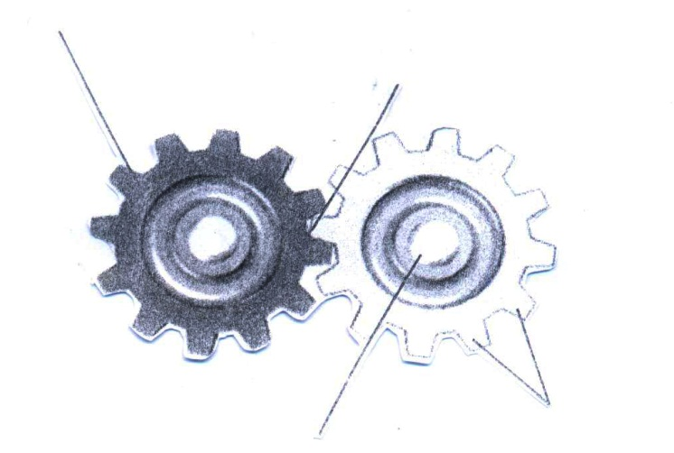
b):Identify the following. /4
Gear
Teeth
Axle
Meshed area

Q No3: Sort the following in the table given below. /10
Water Air Salt Dirt Oxygen
Copper Coke Steel Rain Ice cream
Element | Compound | Mixture | Solution

Q No4:Classify the following as metal / non-metals. [8 marks]
Silver _________________ Iron _______________
Oxygen _________________ Aluminum _______________
Carbon _________________ Calcium _________________
Sulphur _________________ Sodium _________________

b): Identify the type of each pulley. [2 marks]
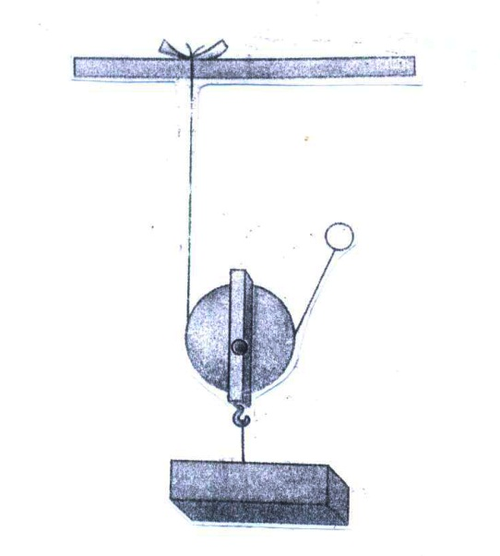

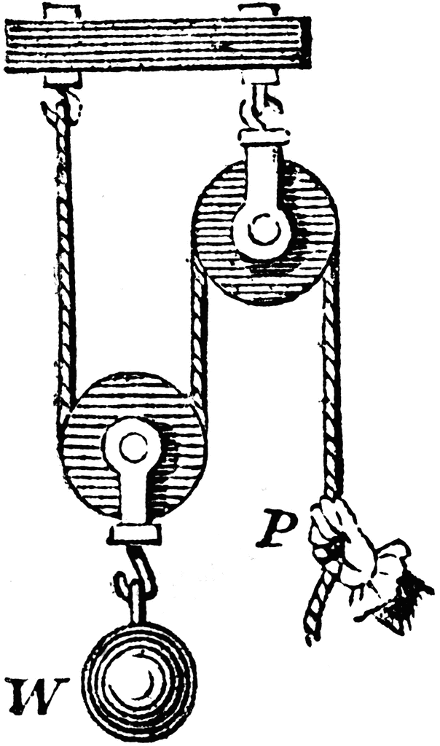

SUBJECTIVE-60marks
Give short answers to any five of the following questions 3x5=15
- Give three ways of separation a mixture?
- Write the physical properties of metals.
- Write properties of mixtures.
- What is a reversible change? Give two examples.
- What kind of mixture can you separate using the filtration method?
- Why is energy of following water renewable?
- What is mater? Name its different components.
- Why is energy from biomass renewable?
Q No2:Answer any four of the following questions. /20
- What is energy? Write the names of different forms of energy.
- Define law of conservation of energy.
- Write physical properties of metals?
- Write various techniques of separating solutions and mixtures.
- What are solutions? Write any three of its characteristics.
- What are reflective surfaces and how can they be useful?
Q No3: Write the symbols of the following elements. /10
Element | Symbol | element | Symbol
Sodium |  | Hydrogen
Aluminum |  | Calcium
Oxygen |  | Carbon
Chlorine |  | Magnesium
Iron |  | Sulphur

Q4) What will be the mass and weight of a 10kg object on the Earth. /5
- Mass = _____________________________
- Weight= ______________________________
Q5) What is the mass and weight of a 10kg object on the moon where force of gravity is1/6th of the Earth’s? /5
- Mass = ____________________________
- Weight= ___________________________
Q No6:Label the diagram of energy conversion. / 5

