AFSS CENTRAL EVALUATION SYSTEM
Central Assessment Team (CAT), HO Islamabad
Final Term/ Annual Examination 2016 – 2017

SCIENCE - Class I
100 marks 3 hours

INFORMATION FOR STUDENTS
Marks are given against each question or part of question.
Write your name, roll number and date in the spaces provided below.
Student Name: | Roll No:
Center Name: | Date:
 | Day:
Invigilator Name: | Sign:
Marks Obtained: | Remarks:
Examiner Name:  Date: | Sign :  Day:

OBJECTIVE-40 marks

Q No1:Fill in the blanks by choosing the words given below. 10
(fish, frog, elephant, crocodile birds, ear, taste, skin, smell, eyes)

- I am one of the biggest animals in the forest Who am I?_________
- I have biggest fins. Who am I?____________
- I have scales all over my body. Who am I?_________________
- I live both on land and in water. Who am I?__________________
- I have wings and feathers. Who am I?_____________
- We hear with our ___________________
- We_________________ with our tongue.
- We touch and feel with the help of our ______________.
- We ______________ with our nose.
- We see with our _______________
Q No2:Put () for the correct answer ad () for the wrong statement. 5
i) Most plants grow flowers. ______
ii) All seeds are of similar shape. ______
iii) A baby plant gets food from the seed. ______
iv) Fruits store seeds for the new plant. ______
v) Leaves make food for the plant. ______

Q No2(b):Choose and circle the material from which each object is made. /5
- Paper
- Plastic
- Plastic
- wood
- glass
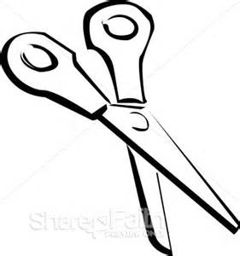 | - Metal  - Plastic  - Wax
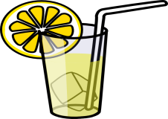 | - Glass  - Wood  - Metal
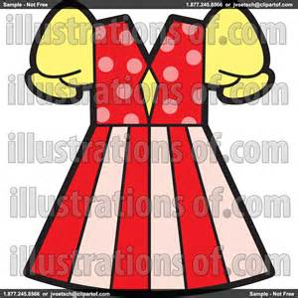 | - Plastic  - Fabric  - Metal

Q No3:Label the picture showing different stages of plant growth. /5

Seedling, root ,seed , leaf ,stem ,flower

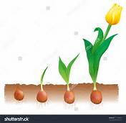
(b): label the parts of the plant. /5
(Bud, Leaf, Flower, Stem, Root)
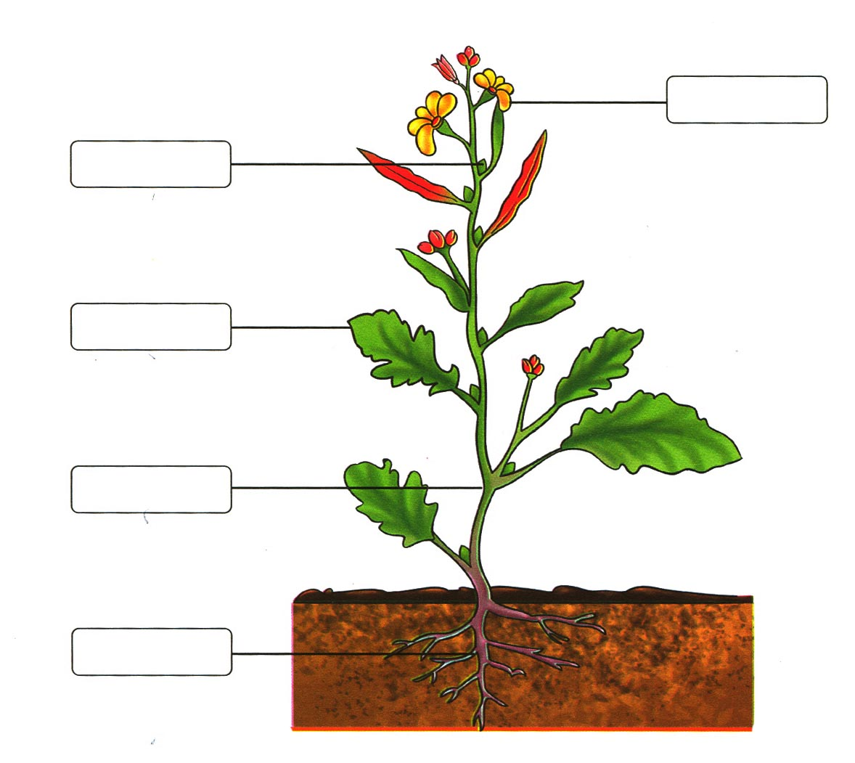
Q No4:Name the animals that give us the following useful things. 6

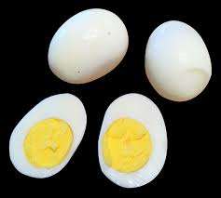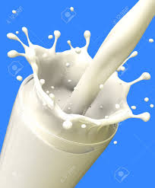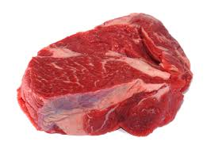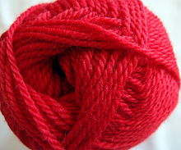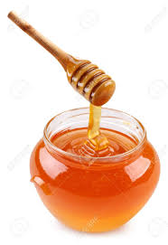
__________ ___________ ___________ ___________ ___________
(b):Write “Push” or “ Pull” in the given boxes to show the force applied.
4
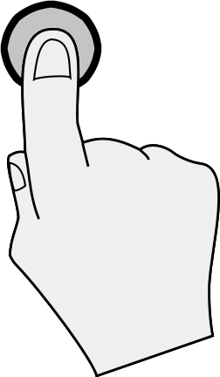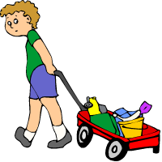

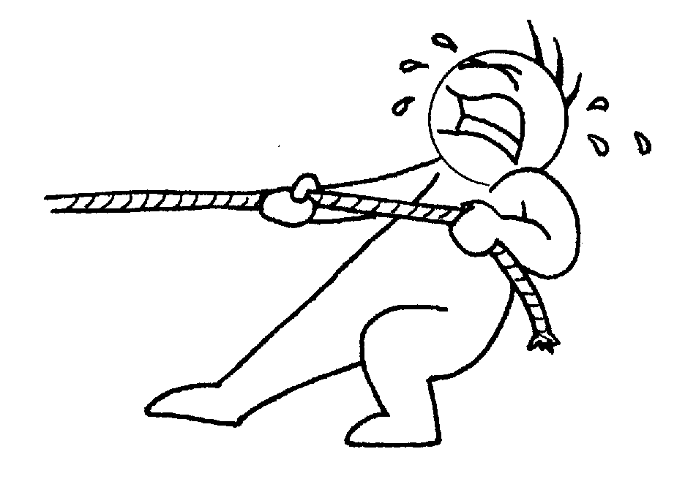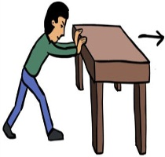

SUBJECTIVE-60 marks

Q No1:Give answers to the following questions. 2 x 10 = 20
i) Name two animals that eat plants only:
1._____________________ 2.___________________________
ii) Name two animals that eat meat only:
1._____________________ 2.___________________________
iii) Name two animals that eat grain:
1._____________________ 2.___________________________
iv) Name two animals that eat plant and animals both:
1._____________________ 2.___________________________
v) Two birds that live in nests:
1._____________________ 2.___________________________
vi) Name the four things that you can see around:
1._____________________ 2.___________________________
vii) An airplane is flying in the sky. Is airplane a living or a non-living thing?
1._____________________ 2.___________________________
viii) Two animals that live in a den
1._____________________ 2.___________________________
ix) Two animals that live in a hole:
1._____________________ 2.___________________________
x) Two animals that live in sheds
1._____________________ 2.___________________________
Q No2(a):Match the animals to their food. 5
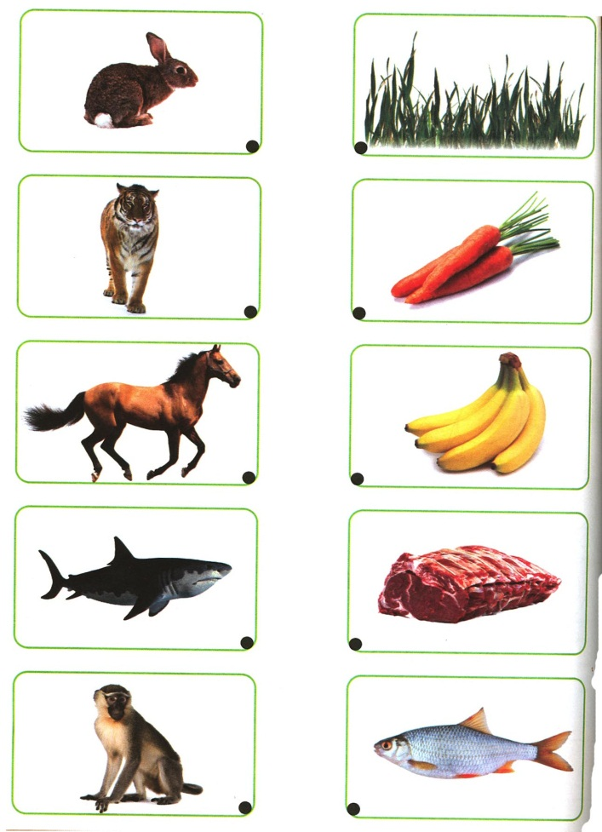
(b):Identify the following materials as Solid or Liquid. 5
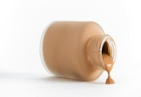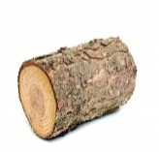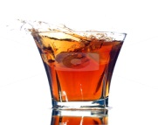

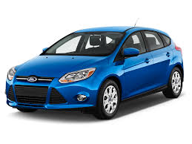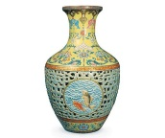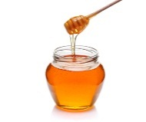

Q No3:Write hard or soft in front of each object. / 5

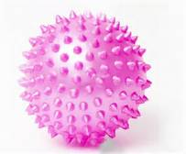 ____________________ 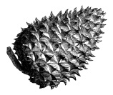 __________________

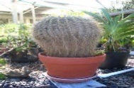 ____________________ 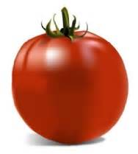 ___________________

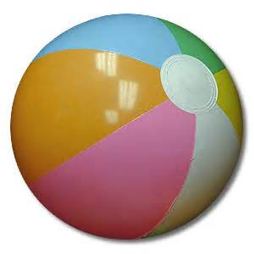 ____________________
(b) Write down the name of the phase of the Moon. /5
_____________________________________________
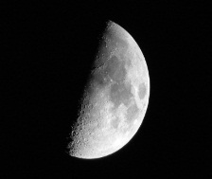

___________________________________________

______________________________

Q No4:What’s the weather like? Write about each of them. /10
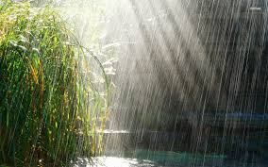
____________________________________________________________________________________________
__________________________________________________________________________
_______________________________________________
_______________________________________________
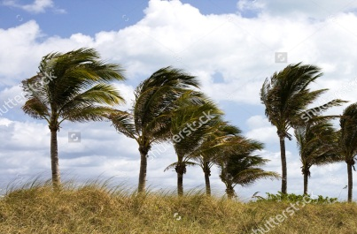
___________________________________________
___________________________________________
___________________________________________

Q No5.What type of sounds each of them makes. /10
 

