AFSS CENTRAL EVALUATION SYSTEM
Central Assessment Team (CAT), HO Islamabad
Final term/Annual Examination 2016– 17

S. STUDIES- Class II
100 marks 3hours

INFORMATION FOR STUDENTS
Marks are given against each question or part of question.
Write your name, roll number and date in the spaces provided below.
Student’s Name: | Roll No:
Center’s Name: | Date:
 | Day:
Invigilator’s Name: | Sign:
Marks Obtained: | Remarks:
Examiner’sName:  Date: | Sign :  Day:

OBJECTIVE-40

Q No1:Write the correct name under each of the following pictures. 6

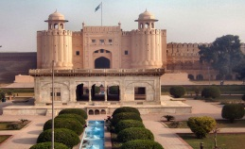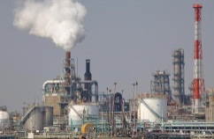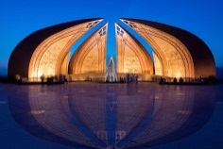

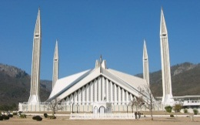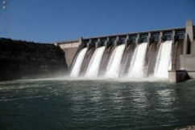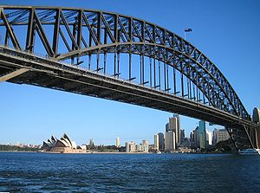

(b):look at the pictures and write what the weather is like? 4
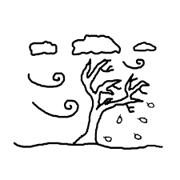 |  | 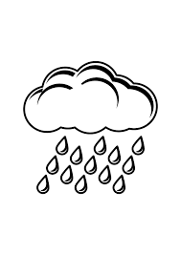 | 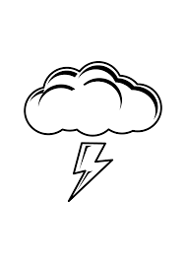

Q No2:Complete this form about your country. 5
- Country:___________________
- Provinces:__________________
- The largest city:_____________
- My favourite place:__________
- Capital:_____________________
(b):Name five plants that we can eat. 5
- ________________ 2.__________________
3._________________ 4.__________________
5._________________
Q No3.Write any five uses of water. 10

i)__________________________________________________________

ii)__________________________________________________________

iii)__________________________________________________________

iv)___________________________________________________________

v)___________________________________________________________

Q No5.Match the following . 5
24 hours in one day
365 days in September
30 days in a minute
366 days in one week
60 seconds in a leap year
12 months in a week
7 days in a year
(b):Write the name of 5 animals which are not dangerous or fierce. 5
1.__________________ 2.________________
3.__________________ 4.________________
5.__________________

SUBJECTIVE-60 marks

Q No1:Answer the following questions. 15x3= 45
- Name two sources of fresh water.
_________________________________________________________
- Why is it important to have clean drinking water?
_________________________________________________________
- What season is it nowadays?
_________________________________________________________
- What is weather?
_________________________________________________________
- What are the colors in a rainbow?
_________________________________________________________
- Why should we be kind to animals?
_________________________________________________________
- Which animals pull carts and wagons?
_________________________________________________________
- How are plants useful for animals?
_______________________________________________________
- What is the island called?
_________________________________________________________
- What work do elephants do?
_________________________________________________________
- What is the difference between day and night?
_________________________________________________________
- When is the sun directly overhead?
_________________________________________________________
- What material are houses made of?
_________________________________________________________
- What parts of your house are made of wood?
________________________________________________________
- Name few things that can be made from plants.

Q No2:Answer the following questions. 5
i)What kind of clothes do you wear in summers?
____________________________________________________________________________________________________________________________________
ii) What kind of clothes do you wear in winters? ____________________________________________________________________________________________________________________________________

Q No3.Colour the picture and write five sentences about it. 10






