AFSS CENTRAL EVALUATION SYSTEM
Central Assessment Team (CAT), HO Islamabad
Final Term/Annual Examination 2016–17

S. STUDIES- Class I
100 marks 3hours

INFORMATION FOR STUDENTS
Marks are given against each question or part of question.
Write your name, roll number and date in the spaces provided below.
Student’s Name: | Roll No:
Center’s Name: | Date:
 | Day:
Invigilator’s Name: | Sign:
Marks Obtained: | Remarks:
Examiner’sName:  Date: | Sign :  Day:

OBJECTIVE-40(marks)
Q No1:Fill in the blanks. 10
- Christians go to a ________________ to pray.
- Hindus pray in a _________________.
- The Holy book of Muslims is called the_______________.
- Muslims follow the religion called_______________.
- Most people in our country are _______________.
- The earth is made up of _____________and______________.
- The earth is shaped like a________________.
- Never look directly at the_______________.
- Birds can fly high up in the______________.
- When it is dark you can see the_______________.
Q No2(a): How many wheels do these type of transport have? 5
i) A bicycle has _______ wheels.
ii) A car has _______ wheels.
iii) A donkey cart has _______ wheels.
iv) A cycle has ___________ wheels.
v) A rickshaw has ________ wheels.
(b) How many people can travel on these vehicles? 5
i) A car __________ iv) A truck __________
ii) A bicycle_________ v) A Scooter __________
iii) A cart __________

Q No3:write one word for each of the following: 5
- A person who works in a bank:_______________
- A person who flies an aeroplane:_____________
- A person who grows flowers:________________
- A person who makes things out of wood:____________
- A person who treats us:_____________
(b):Match the animals, birds, and insects with their homes. 5
Ants | Spiders | Birds | Snakes | Bees | Mice

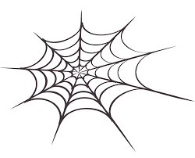 |  | 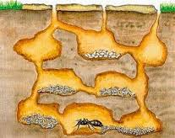 | 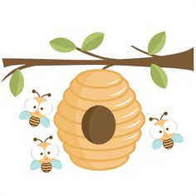 | 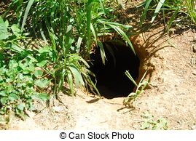

Q No4(a):Write the names of three things found in a village and three things found in a city. 6
In a city In a village
1._________ 1.___________
2.___________ 2.__________
3.____________ 3.____________
(b):Complete the following with right words. 4
i) The sky is high _____________ the Earth.
ii) It is __________ at night.
iii) Can you___________ lift this for me?
iv) I spilled the water. I am ________________.

SUBJECTIVE-60(marks)

Q No1:Write the name of the following flowers. 8
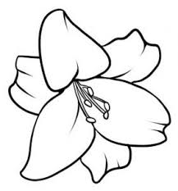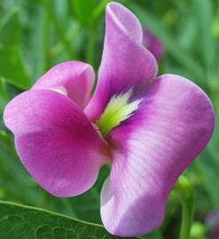

Q No2:Write the names of 10 animals. 10
________________ ________________

________________ ________________

________________ ________________

________________ ________________

________________ ________________

QNo3: Answer the following questions. 2×15=30
- Do you help people? How?
__________________________________________________________________________________________________________________________
- Where do Muslims pray?
__________________________________________________________________________________________________________________________
- What is the name of Christian`s holy book?
__________________________________________________________________________________________________________________________
- Which religion Muslims follow?
__________________________________________________________________________________________________________________________
- How should people take care of their pets?
__________________________________________________________________________________________________________________________
- What is the name of bird’s home?
__________________________________________________________________________________________________________________________

- What is the name of your city?
__________________________________________________________________________________________________________________________
- Where would you like to live?
__________________________________________________________________________________________________________________________
- What are some important places near your home?
__________________________________________________________________________________________________________________________
- What is your favourite type of transport?
__________________________________________________________________________________________________________________________

- How do you come to school every day?
__________________________________________________________________________________________________________________________
- What does sea water taste like?
__________________________________________________________________________________________________________________________
- What can you see in the sky during the day? __________________________________________________________________________________________________________________________
- Write about the things you can see in the sky? ______________________________________________________________________________________________________________________________
- What is the shape of the earth? ______________________________________________________________________________________________________________________________

QNo4:Draw a picture of your pet, or the one you would like to have and fill in
the blanks. 12

- I have a pet___________________
- My pet’s name is _______________
- Its colour is ___________________
- It has lovely __________eyes.
- Its favourite food is___________
- My pet is very ______________

