AFSS CENTRAL EVALUATION SYSTEM
Central Assessment Team (CAT), HO Islamabad
Final Term/ Annual Examination 2016 – 2017

MATHEMATICS - Class III
100 marks 3 hours

INFORMATION FOR STUDENTS
Marks are given against each question or part of question.
Write your name, roll number and date in the spaces provided below.
Student’s Name: | Roll No:
Center’s Name: | Date:
 | Day:
Invigilator’s Name: | Sign:
Marks Obtained: | Remarks:
Examiner’s Name:  Date: | Sign :  Day:

OBJECTIVE-40marks

Q No1:Fill in the blanks. 10
i) $\frac{1}{4}$ hour = _________________ minutes .
ii) There are _________________ minutes in every day.
iii) There are _________________ hours in every morning part of the day.
iv) 10 minutes + 40minutes + _________________ minutes = 1 hour
v) 64 ÷ 8 = _________________
vi) 13 × 1000 = _________________
vii) 8000 + 100 + 70 + 2 = _________________.
viii) There are _________________ paise in Rs.3.
ix) 8 × ______ = 0
x) $\frac{6}{9}+\frac{3}{9}=\frac{ }{ }$
Q No2(i):Write the following fractions in ascending order. 10
i) $\frac{3}{9} , \frac{5}{9} , \frac{8}{9} , \frac{1}{9}$
_____________________________________________________________
ii)Write the value of the circled digit.
a) 2 0 8 _________ (b) 1 8 9 6 __________
iii)Write the following numbers in words:
- 108 ____________________________________________
- 9999____________________________________________
iv)Fill in ‘<’ or ‘>’.
a) 6012 _______ 8199

v) Filling in the missing numbers
a) 1012 _____, _____ ,_____ 5012 _____, _____
b) 500 x 10 = ______________

Q.No.3:a) What times do the clocks show? Write in words and in numbers. /10
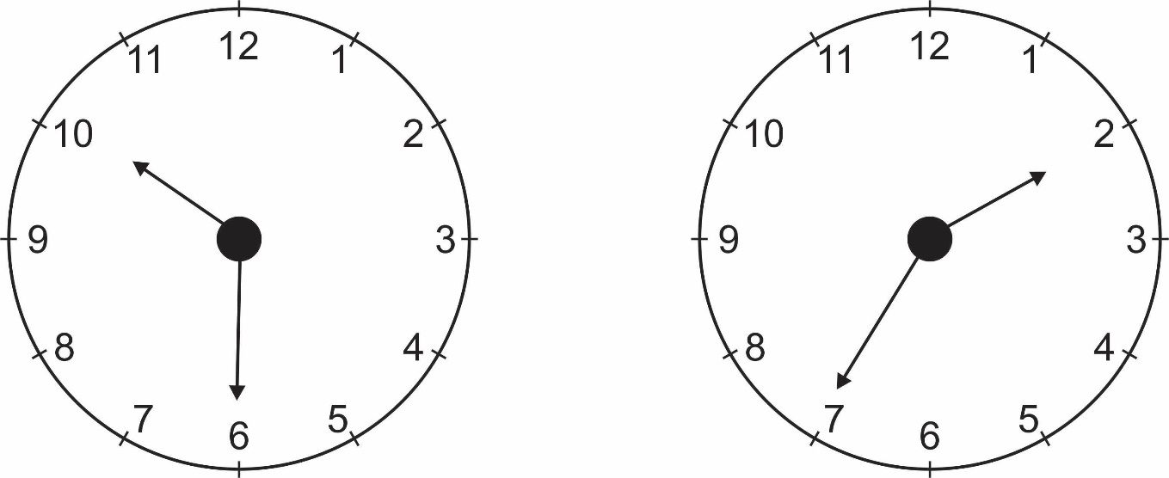

b) Write true or false. 5
i) A day has 16 hours.
ii) Noon comes after morning.
iii) Every day begins at midnight.
iv) Tuesday is a day of the week.
v) Midnight comes after 11PM.

Q No4:Tick () at the correct answer. 5
i) The product of 24 and 10 is
a) 240 (b) 140 (c) 340 (d) 190
ii) Which one of the following is not equivalent to $\frac{4}{6}$
a) $\frac{2}{3}$ (b) $\frac{8}{10}$ (c) $\frac{6}{9}$ (d) $\frac{8}{12}$
iii) Evaluate $\frac{2}{6}+\frac{2}{6}+\frac{3}{6}$ , the answer is:
a) $\frac{7}{6}$ (b) $\frac{1}{6}$ (c) $\frac{2}{4}$ (d) $\frac{5}{9}$
iv) A pizza is cut into 8 equal portions. Ahsan eats 3 pieces.What fraction of the pizza is left?
a) $\frac{4}{8}$ (b) $\frac{5}{8}$ (c) $\frac{2}{8}$ (d) $\frac{9}{10}$
v) There are ____________ minutes in 6 hours.
a) 120 minutes (b) 360 minutes (c) 180 minutes (d) 240 minutes

Q No5:Write the fraction of each set which are coloured. 5
i) ___________

ii)
__________

SUBJECTIVE-60marks

Solve any six of the following questions. 10 x 6 = 60
Q No1(a):Multiply
- 912 x 6 ii) 2556 x 4

(b):Divide the following:
i) $8\sqrt{88}$ ii) $6\sqrt{684}$
Q No2(a):Write in roman numbers
i) 6 (ii) 35
Write the Arabic numeral for
i) XVII (ii) XX
(b):Mani had Rs.90. He gave Rs.65.60 to his friend Amir.
How much money was Mani left with?
Q No3(a):Add the following sums
i) Rs. 21.60 ii) Rs. 50.05
+ Rs. 44.25 + Rs. 27.50

(b):Subtract the following

i) 4 km 475 m ii) 22m 15cm
_ 1 km 565 m _ 11m 25cm

Q No4(a):Find out how many minutes in
i) 6h 10 mint (ii) 3 h 40min
(b):Class 3B is going for a picnic. There are 42 children in the class and each
child must pay Rs.7. How much money will be collected altogether?
Q No5(a):Solve the following division sum
9 kg 205 g ÷ 5
(b): Add & subtract the following fractions:
i) $\frac{8}{10}-\frac{2}{10}=\frac{ }{ }$ ii) $\frac{2}{6}+\frac{6}{6}=\frac{ }{ }$
Q No6(a):Ahmad has two buckets. One bucket holds 6l 450ml while the other holds 3 l 180ml. Find the total capacity of two buckets.
(b):How many is
(i) $\frac{1}{4}$ of 12 books? ii) $\frac{1}{24}$ of 4 houses?
Q No7:There are 650 lemons to be put into bags.
(a):How many bags of 7 lemons each can be filled?
(b):How many lemons are left over?
Q No8: Name each of the following shapes.

(b):A triangle has sides 10cm and 8cm. What is its perimeter?

