AFSS CENTRAL EVALUATION SYSTEM
Central Assessment Team (CAT), HO Islamabad
Final Term/ Annual Examination 2016– 2017

MATHEMATICS - Class II
100 marks 3 hours

INFORMATION FOR STUDENTS
Marks are given against each question or part of question.
Write your name, roll number and date in the spaces provided below.
Student’s Name: | Roll No:
Center’s Name: | Date:
 | Day:
Invigilator’s Name: | Sign:
Marks Obtained: | Remarks:
Examiner’s Name:  Date: | Sign :  Day:

OBJECTIVE-40marks

Q No1:Fill in the blanks. 10
i) 500ml ×________ = 1000ml
ii) 6 × 8 = ________
iii) 24 ÷ _________ = 6
iv) 40 ÷ _________= 8
v) A sphere has only ________________ face.
vi) There are ________________ days in a September.
vii) A cone has ________________ faces.
viii) In a leap year, there are ________________ days.
ix) 500 ml × _______________ = 1000 ml = _______________.
x) The first month of the year is _______________________.
Q No2:Write the numbers in words. 10
i) 284 ____________________________________________________
ii) 119 ____________________________________________________
Write in numbers.
iii) Six hundred and thirty __________________________________
iv) Eight hundred and five __________________________________
v) Put these numbers in descending order:
624 , 738 , 783 , 599 , 629 , 621
_____________________________________________________

vi) Write ‘<’ or ‘>’ in the boxes.
396 384 , 692 792
3
3
vii) Count in 6’s and fill in the missing numbers
12 ________ , _______ , _________ , 36 , 42 ________ , ________
viii) Complete these:
50 × 0 = , × 10 = 0
ix) Put these numbers on ascending order:
232 , 248 , 223 , 218 , 281 , 110
_____________________________________________________
x) 5 × = 30
Q No3(a):Join each shape to its name from the list. 5
Cuboid
Cylinder
Cone
Sphere
Cube
Q No3(b):Choose the correct answer and circle it. 5
i) What number is 100 less than 159?
a) 100 (b) 5 (c) 59 (d) 109
ii) There are _____ days in 4 weeks
a) 21 days (b) 23 days (c) 28 days (d) 35 days
iii) What is the value of ‘7’ in the number of 780?
a) 7 (b) 70 (c) 700 (d) 7000
iv) A pizza is cut into 4 equal parts .One part is eaten. What fraction of the pizza is left?
a) $\frac{2}{3}$ (b) $\frac{3}{4}$ (c) $\frac{1}{4}$ (d) $\frac{2}{4}$
v) How many vertices does a cube have?
a) 6 (b) 9 (c) 8 (d) 10

176 | 289 | 342 | 999 | 500
457 | 250 | 450 | 618 | 550
400 | 110 | 803 | 199 | 852
645 | 375 | 210 | 700 | 305
Q No4:Look at the numbers on the table and answer the questions below. 10

a) The largest even number ______________________
b) The smallest odd number _____________________
c) Write all the numbers that are less than 200.
_________________________________________________________
_________________________________________________________
d) Which number is one less than one thousand?
_________________________________________________________
e) Which two even numbers add up to 900?
___________________ and _________________.
f) The sum of the first and the last number on the grid is
_________________________________________________________

SUBJECTIVE-60marks

Solve any six of the following questions. 10x6=60
Q No1(a):One sweet costs 5 rupees. Sabeen buys 6. How much money does she spend? 5
(b): Write the table of 8. 5
Q No2(a):Aysha buys 500g of peanuts, 100g of coffee, and 50g of cashew nuts.
What is the total weight? 5

(b):How many threes are there in? 5
How many fives are there in ?
15 ÷ 3 =
15 ÷ 5 =

Q No3(a):Write the fraction of coloured part of the following figures? 5

b)What time does each clock show? 5
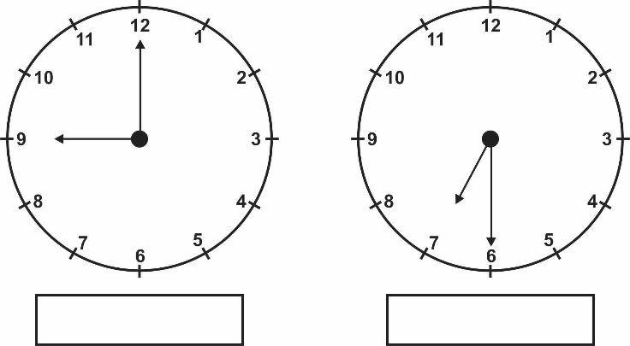
Q No4:Multiply the following (any five). 10
i) T O ii) T O iii) T O
1 5 1 2 9
× 4 × 2 × 4

iv) T O v) T O vi) T O
1 0 7 1 0
× 4 × 8 × 9

Q No5:Add the following. 10
i) 5 m 18 cm ii) 27 m 20 cm
+ 2 m 67 cm + 12 m 10 cm

iii) Rs. 1 0 iv) Rs. 4 8
+ Rs. 2 8 + Rs. 2

v) 5 0 m
+ 2 9 m

Q No6:Subtract the following. 10
i) 4 m 29 cm ii) 42 m 53 cm
- 3 m 21 cm - 29 m 29 cm

iii) 92 l 620 ml iv) 9 6
- 74 l 280 ml - 5 5

v) 6 0 9 vi 8 1 1
- 1 9 1 - 6 8 4

Q No7:Divide the following (any 5). 10

- $5\sqrt{25}$ ii) $10\sqrt{100}$ iii) $3\sqrt{30}$

iv) $6\sqrt{36}$ v)$6\sqrt{42}$ vi) $10\sqrt{100}$

