AFSS CENTRAL EVALUATION SYSTEM
Central Assessment Team (CAT), HO Islamabad
Final Term/ Annual Examination 2016– 2017

Art & Craft - Class IV
50 marks 2 hours

INFORMATION FOR STUDENTS
Marks are given against each question or part of question.
Write your name, roll number and date in the spaces provided below.
Student Name: | Roll No:
Center Name: | Date:
 | Day:
Invigilator Name: | Sign:
Marks Obtained: | Remarks:
Examiner Name:  Date: | Sign :  Day:

Q1. Draw a banner to encourage everyone to SAVE WATER. 10

Q.2 Decorate the tortoise by placing glasses and wool on its back. Also paste rice on it. Colour the rest of the tortoise and paint it. 10

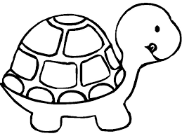

Q 3: Draw a picture of a plant with pencil. Use broomsticks as stems and make leaves by dipping natural leaves in the green water colour and giving their impression on the branches of your plant. 10

Q 4: Paste Sutli on the ladybird’s circles in the round shape. Also put Rubber bands on the legs and antennas. Paint the rest of the picture as well. 10

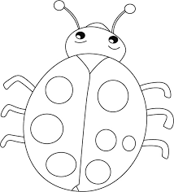
Q 5: Complete the picture and colour it. 10
