AFSS CENTRAL EVALUATION SYSTEM
Central Assessment Team (CAT), HO Islamabad
2nd Mid Term Examination 2016 – 17

SCIENCE - Class III
50 marks 2 hours

INFORMATION FOR STUDENTS
Marks are given against each question or part of question.
Write your name, roll number and date in the spaces provided below.
Student Name: | Roll No:
Center Name: | Date:
 | Day:
Invigilator Name: | Sign:
Marks Obtained: | Remarks:
Examiner Name:  Date: | Sign :  Day:

OBJECTIVE-20marks

Q No1:Fill in the blanks. 5
- __________ travels in straight lines.
- Plants also use the energy to prepare food through _____________.
- Water boils at ___________⁰C.
- ___________ does not have definite shape.
- The cylinders that are used to measure water are _____________.
Q No2: Choose the best answer. 5
i. Granite is _____________.
a) permeable b) impermeable
c) absorbent d) none of the above
ii. When magma cools and solidifies, it forms _______________.
a) igneous rock b) sedimentary rock c) metamorphic rock d) all of the above
iii. Furniture is made up of ____________.
a) wood b) bricks c)cotton d) none of the above
iv. Often we get medicines from ____________.
a) animals b) field c) plants d) none of the above
v. Pesticides are some special _____________.
a) gas b) flakes c) chemicals d)none of the above

Q No 3:Match the pictures with the name. 5
Pesticides | 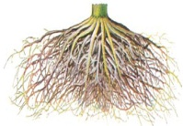
Soil | 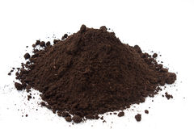
Stem | 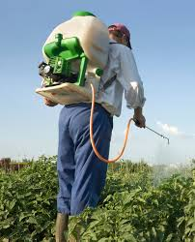
Plant | 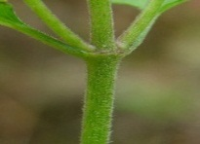
Roots | 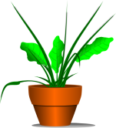

Q No 4:Identify the statements that are false, write F. 5
- We apply brakes to speed up the cars. _____
- Weight is the quantity of an object. _____
- Mass can never be zero. _____
- Astronauts are weightless in space. _____
- Spring balance is used to measure mass. _____
SUBJECTIVE-30marks
Q No1: Answer any five of the following questions. 3 × 5 = 15
i. How plants helps in lowering temperature?
ii. Differentiate between elasticity and flexibility.
iii. What is rainbow?
iv. Give three ways to reduce the friction.
v. Write down the differences between mass and weight.
vi. How is sound energy produced?
vii. Name the steps of water cycle.

Q No2: Write the meanings of the following words. 5
Words | Meanings
Conductor
Gravity
Refraction
Alloy
Flexible
Q No2: Name the materials under the following columns. 10
Solids | liquids | Gas

