AFSS CENTRAL EVALUATION SYSTEM
Central Assessment Team (CAT), HO Islamabad
2nd Mid Term Examination 2016 – 17

SCIENCE - Class I
50 marks 2 hours

INFORMATION FOR STUDENTS
Marks are given against each question or part of question.
Write your name, roll number and date in the spaces provided below.
Student Name: | Roll No:
Center Name: | Date:
 | Day:
Invigilator Name: | Sign:
Marks Obtained: | Remarks:
Examiner Name:  Date: | Sign :  Day:

OBJECTIVE-20

Q No 1:Fill in the blanks choosing the right words. 5
i). Plants grow from _______________. ( seeds / flowers )
ii). Some flowers change into ____________. ( seeds / fruits)
iii). Fruit bear _______________. ( seeds / baby plants )
iv). Seeds have ______________ inside them. ( water / baby plants )
v). Leaves are usually ____________. ( green / brown )
Q No2:Identify the materials as solid or liquid. 6
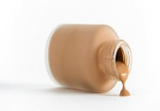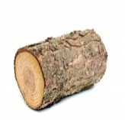

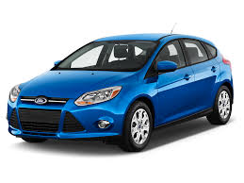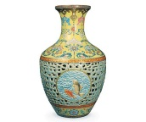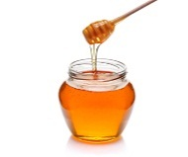

Q No 3:Label the parts of the plants. 5
bud , leaf , flower , stem , root

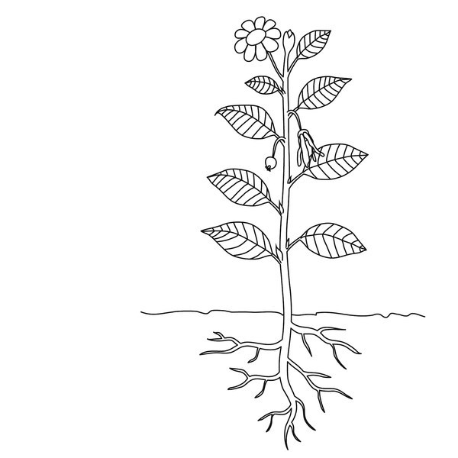
Q No 4:Write “Push” or “ Pull” in the given boxes to show the force applied.
4
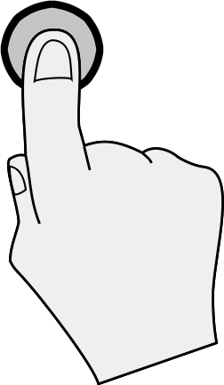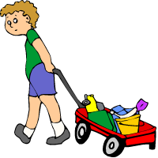

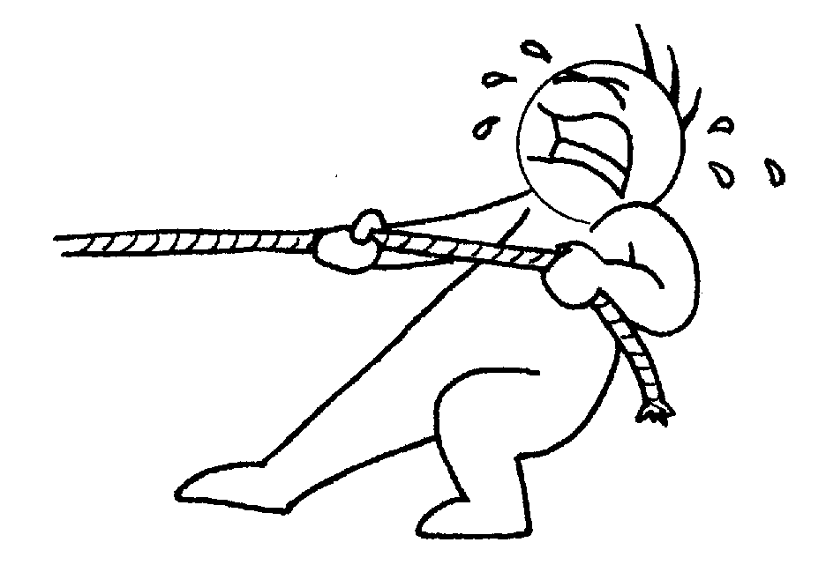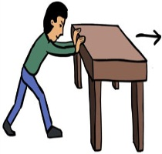

SUBJECTIVE-30

Answer the following questions. 5x4= 20
Q No 1: How many types of the sounds? Write their names.

__________________________________________________________________
Q No 2: How is milk good for us?

__________________________________________________________________
Q No 3: Which things are required for plant growth?

__________________________________________________________________
Q No 4: Write the names of the five things which are made up of glass?

__________________________________________________________________
Q No 5: What is the material? Write the two main types of the materials.

Q No 6:Write the characteristic of each object in the table. 10
Size: small, large, big, little
Shape: circle, triangle, rectangle, square
Weight: heavy, light

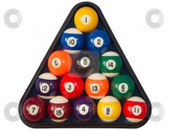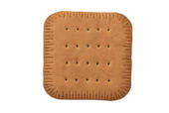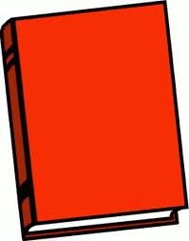

Objects | Shape | Size | Weight
Balloon
Cushion
Pyramid
Book

