AFSS CENTRAL EVALUATION SYSTEM
Central Assessment Team (CAT), HO Islamabad
2nd Mid Term Examination 2016 –17

S. STUDIES - Class I
50 marks 2 hours

INFORMATION FOR STUDENTS
Marks are given against each question or part of question.
Write your name, roll number and date in the spaces provided below.
Student’s Name: | Roll No:
Center’s Name: | Date:
 | Day:
Invigilator’s Name: | Sign:
Marks Obtained: | Remarks:
Examiner’sName:  Date: | Sign :  Day:

OBJECTIVE-20(marks)
Q No 1:Write the names of three things found in a village and a city. 6

In a city In a village

i. ____________ i. ____________
ii.____________ ii.____________
iii.____________ iii.____________
Q No 2:Write one word for each of the following. 4
- A person who works in a bank:_______________
- A person who flies aeroplanes:_______________
- A person who grows flowers: _______________
- A person who makes things out of wood:_______________
Q No 3: Put a circle round the things you learnt at school. 4
sums | writing | reading | Fighting
dancing | drawing | shouting | Games
flying | handicrafts | bad manners | Singing

Q No 2:Write the names of animals, birds, and insects with their homes. 6
ants | spiders | birds | snakes | bees | mice

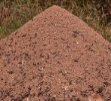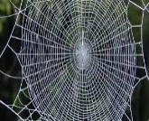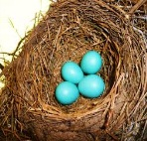

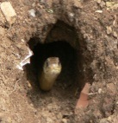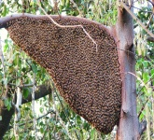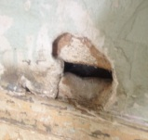

SUBJECTIVE-30(marks)

Q No 1:Answer any four of the following questions. 5 x 3= 15
- Do you live in a city or a village?
- Where do Muslims pray?
- Where do Hindus pray?
- Does your School have a garden?
- Which animals make good pets?
- How should people take care of their pets?
Q No 2:Colour in the picture. 5
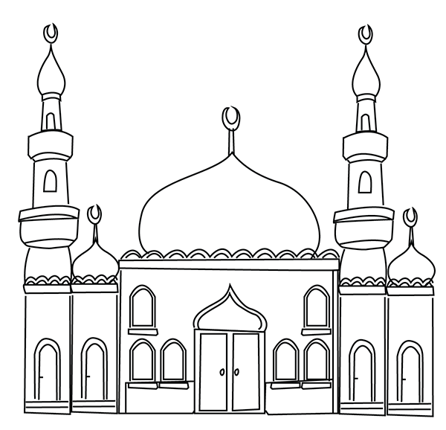

Q No 3:Make the list of five jobs that people do. 5
- _______________
- _______________
- _______________
- _______________
- _______________

