AFSS CENTRAL EVALUATION SYSTEM
Central Assessment Team (CAT), HO Islamabad
2nd Mid Term Examination 2016 – 17

MATHEMATICS - Class II
50 marks 2 hours
INFORMATION FOR STUDENTS
Marks are given against each question or part of question.
Write your name, roll number and date in the spaces provided below.
Student’s Name: | Roll No:
Center’s Name: | Date:
 | Day:
Invigilator’s Name: | Sign:
Marks Obtained: | Remarks:
Examiner’s Name:  Date: | Sign :  Day:

OBJECTIVE – 20(marks)
Q No1:Fill in the blanks. 10
- The month before May is ___________.
- The last month of the year is __________.
- There are _______ or _______ days in a month, except for February which has only _______ or ______ days.
- A cube has ________ vertices.
- 1 five-rupees coin = ______ one –rupee coins.
- I have six faces and eight vertices. What am I? ___________.
- There is a number to be divided. It is called the ___________.
- 5 x 9= _______.
- 0 x 4= _______.
- 18 ÷ 9= _______.
Q No 2: Join each shape to its name from the list. 5

Cuboid
Cylinder
Cone
Sphere
cube
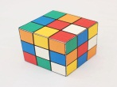
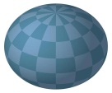
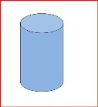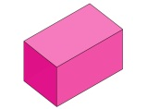

Q No 3: Tick () the sums which make rupees 50: 5
- Rs 10 + Rs 28 _____
- Rs10 x 5 _____
Fill in +, - , × or ÷ in the boxes.
- 100 20 = 80
- 18 6 = 3
- 4 9 = 36

SUBJECTIVE – 30
Solve the following questions. 3x10=30
Q No 1(a):A sum of Rs.36 is to be shared equally among 4 children. How
much does each child get?
(b): 8 √ 56 6 √ 36

Q No 2(a): Aslam has 8 bowls with 7gold fishes in each bowl. How many fishes
are there altogether?
(b): Multiply the following sums:
3 5 5 2 7 0
x 2 x 3

Q No 3(a):How many threes are there in 15?
15 ÷ 3 =
How many fives are there in 15?
15 ÷ 5=
(b): Find the total cost:
Rs. 76 Rs. 36
Rs. 11 Rs. 27

