AFSS CENTRAL EVALUATION SYSTEM
Central Assessment Team (CAT), HO Islamabad
2nd Mid Term Examination 2016 – 17

COMPUTER - Class I
50 marks 2 hours

INFORMATION FOR STUDENTS
Marks are given against each question or part of question.
Write your name, roll number and date in the spaces provided below.
Student Name: | Roll No:
Center Name: | Date:
 | Day:
Invigilator Name: | Sign:
Marks Obtained: | Remarks:
Examiner Name:  Date: | Sign :  Day:

OBJECTIVE-20(marks)

Q No1:Choose the correct word and write in the space provided. 5
i) _____________helps you to type alphabets and numbers.
a) Mouse b) Keyboard c) CPU
ii) 0,1,2,3,4 …….. are ______________keys.
- Natural b) Alphabet c)Number
iii) _________key is used to erase the previous character.
- Backspace b) Enter c) Caps lock
iv) __________ is used to see pictures, alphabet, numbers.
- Mouse b) Monitor c) Monkey
v) Keyboard has small buttons called ________________.
a) keys b) Kites c) Knees

Q No 2:Tick () the correct and cross () the wrong ones. 5

i) Space bar key is used to insert blank space.______
ii) Caps lock key is used to write small letters. ______
iii) Keyboard does not help you to type. ______
iv) Backspace key is used to erase the previous letters.______
v) Enter key is the longest key._______
Q No 3: Fill in the blanks. 5
26
Number
Space bar
alphabet
enter

- The _____________ is longest key on the keyboard.
- There are___________ alphabet keys.
- The___________ keys are used for typing words.
- The __________ keys is used to move the next line.
- The __________key are used for typing numbers.
Q No 4: Choose the correct word and write it under the picture. 5
scanner, tower case, monitor, mouse, digital camera, printer
keyboard, trackball, speakers

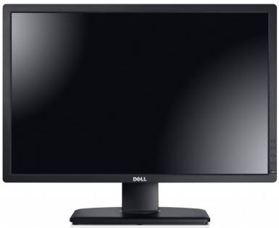 | 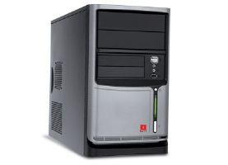 | 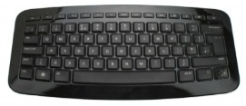
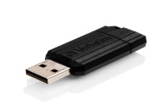 | 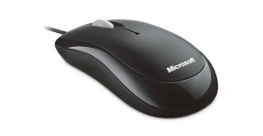 | 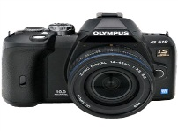
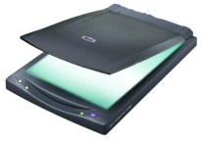 | 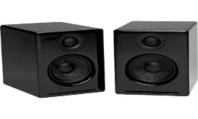 | 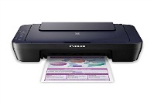

SUBJECTIVE-30(marks)

Q No 1:Answer the following questions. 4x5=20

- Which key is used to insert blank space between two words?
_________________________________________________

_________________________________________________
- Name four things that a computer helps us to do?
________________________________________________

________________________________________________

- Name four machines that you see at your home.
________________________________________________

________________________________________________
- Which key is used to move to the next line?

_______________________________________________

_______________________________________________

- Which part of a computer is like a TV?
______________________________________________

______________________________________________

Q No 2: Color the alphabet keys. 5
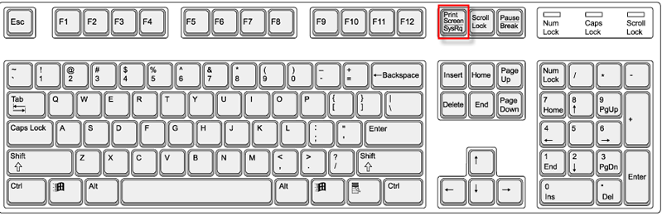
Q No 3: Rearrange the jumbled words. 5
- OMON

- OMPUCRTE

- RFUTI
- APSCEABR
- EKYBAODR

