AFSS CENTRAL EVALUATION SYSTEM
Central Assessment Team (CAT), HO Islamabad
1st Term Examination 2016 – 17

SCIENCE - Class II
50 marks 2 hours

INFORMATION FOR STUDENTS
Marks are given against each question or part of question.
Write your name, roll number and date in the spaces provided below.
Student Name: | Roll No:
Center Name: | Date:
 | Day:
Invigilator Name: | Sign:
Marks Obtained: | Remarks:
Examiner Name:  Date: | Sign :  Day:

OBJECTIVE-20(marks)

Q No1:Fill in the blanks. 6
1) _____________ do not have any backbones or spinal column.
2) _____________ have a pouch in their body.
3) _____________ have two antennae.
4) _____________ are used as the primary producer of silk.
5) Frogs and birds both lay _____________.
6) In the life cycle to butterfly, caterpillar develop into _____________.
7) I have two humps. I live in desert. Which animal am I? _________.
Q No2:Encircle the correct answer. 4
1. Which of the following animals live only in forests.
a) lion b) dog c) cat d) hen
2) All of the animals below live in ponds except _____________.
a) frog b) dog c) newt d) duck
3) Birds live in ____________________.
a) Shed b) Kennel c) nest d) Koop
4) A desert is typically an area that receives extremely _______ amount of rain.
a) Low b) High c) None of the above d) all of the above

Q No 3:Write about the function of each given part of the eye. 10
Iris
Pupil
Lens
Retina
Optic Nerve

SUBJECTIVE-30(marks)

Q. No 1:Answer any five of the following questions. 4 × 5 = 20
i) What are the three R’s?
ii) What is fertile soil?
iii) Differentiate between vertebrates and invertebrates?
iv) Give three things that you should do to save the environment?
v) How can you improve the environment?
vi) Write any two features of Insect and birds.
Q No2:Lable the life cycle of Frog. 5

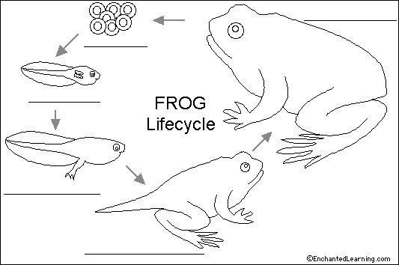

Q No3:Investigate our sense of taste and smell .Tell what will be the taste
of every food item. Choose from sweet, sour, bitter, cold and salty. 5

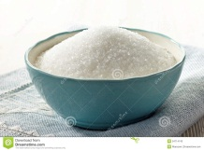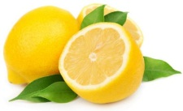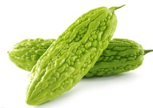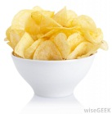
Sugar Lemon Bitter gourd Potato chips

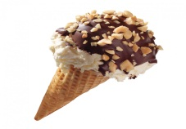
Ice- cream

