AFSS CENTRAL EVALUATION SYSTEM
Central Assessment Team (CAT), HO Islamabad
1st Term Examination 2016 – 17

SCIENCE - Class III
50 marks 2 hours

INFORMATION FOR STUDENTS
Marks are given against each question or part of question.
Write your name, roll number and date in the spaces provided below.
Student Name: | Roll No:
Center Name: | Date:
 | Day:
Invigilator Name: | Sign:
Marks Obtained: | Remarks:
Examiner Name:  Date: | Sign :  Day:

OBJECTIVE-20marks

Q No1:Choose the best answer. 5
1) ___________ are called flesh eating animals.
a) Carnivores b) Herbivores
c) both of the above d) none of the above
2) Muscles are made up of _______________.
a) Fibers b) Threads c) Sugar d) None of these
3) ___________ is necessary for bones.
a) calcium b) vitamin c) magnesium d) iron
4) Animals need ___________ to grow and move.
a) Petrol b) energy c) Fuel d) all of these
5) The smallest bones are in the __________.
a) Eye b) ear c) nose d) leg
6) Some animals eat both plants and animals. These animals are called
____________________.
- Herbivores b) carnivores c) omnivores d) all of the above
7) There are more than __________ muscles in our body.
a) 500 b) 600 c) 700 d) 800
8) Which of the following is not an omnivores?
a) human being b) crow c) giraffe d) bear
9) The process that removes waste products from the body is called
a) Excretion b) reproduction c) digestion d. none of the above.
10) ______________ is the series of stages through which a living organism
passes during its life time.
- Carbon cycle b) Life cycle c) Nitrogen cycle d) all of the above
Q No 3:Animals live in different habitats can you match the animals below to their habitats? Draw a line from the animal to the place in the world where it lives. 5
Australia | 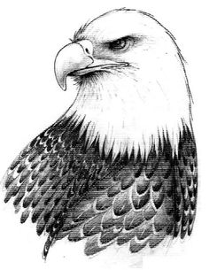
Asia | 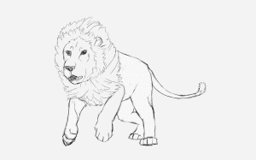
North America | 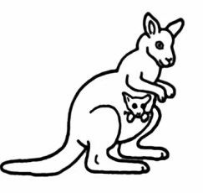
Antarctica | 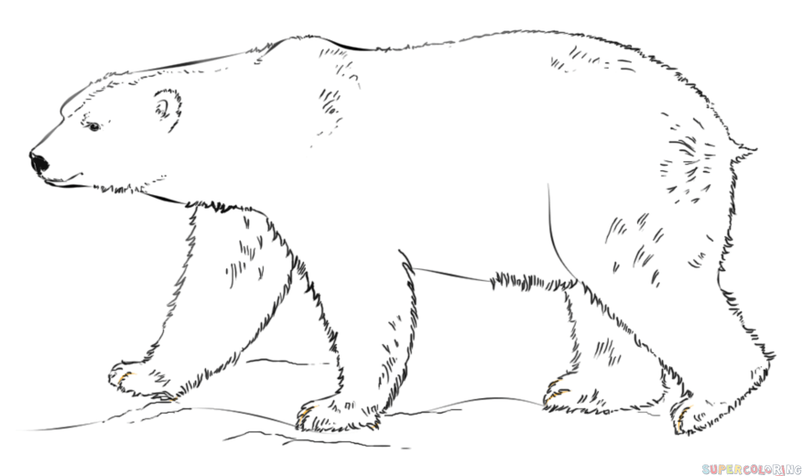
Africa | 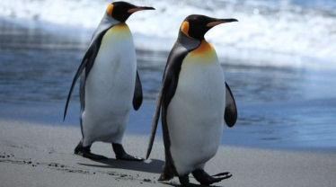

SUBJECTIVE-30marks

Q No1:Answer any five of the following questions. 4 × 5 = 20
i) Where can you find the polar bears?
ii) What is habitat?
iii) Define the herbivores?
iv) Describe the characteristics of mammals?
v) Define omnivores.
vi) Differentiate sanctuaries from safaris?
vii) What are the adaptations that cacti have to survive in deserts?

Q No2:Write the glossary of the following words. 5
Words
Habitat
Adaptation
Carnivores
Amphibian
Respiration

Q No2: Draw and Describe the life cycle of butterfly. 5

