AFSS CENTRAL EVALUATION SYSTEM
Central Assessment Team (CAT), HO Islamabad
1st Term Examination 2016 – 17

SCIENCE - Class I
50 marks 2 hours

INFORMATION FOR STUDENTS
Marks are given against each question or part of question.
Write your name, roll number and date in the spaces provided below.
Student Name: | Roll No:
Center Name: | Date:
 | Day:
Invigilator Name: | Sign:
Marks Obtained: | Remarks:
Examiner Name:  Date: | Sign :  Day:

OBJECTIVE-20

Q No. 1:Fill in the blanks using the following words. 7
Fish, Frog, Elephant, Crocodile, Birds, non-living
1) I am one of the biggest animals in the forest. Who am I? ___________
2) I have the biggest fins. Who am I? ___________
3) I have scales all over my body. Who am I? _______________
4) I live both on land and in water. Who am I? _______________
5) I have wings and feathers . Who am I? _______________
6) Rocks and stones are ____________ things.
7) Living things ____________ by themselves.
Q No2:Match the animals to their food. 5
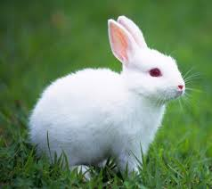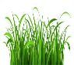
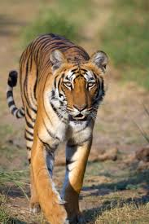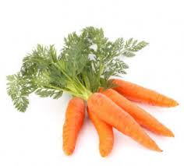
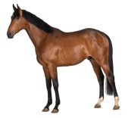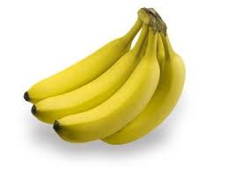
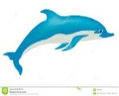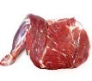
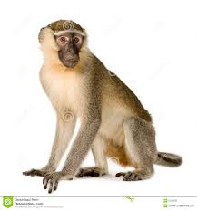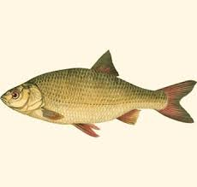

Q No 3:Some animal’s name got jumbled up, rewrite them correctly. 8
ankgoaro ____________  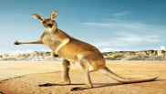 | Phelante ___________  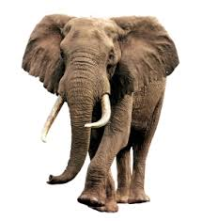
Bzera _________  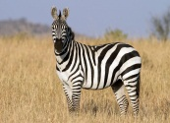 | ertig ____________  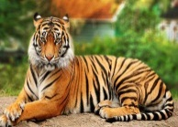
Owlf ___________  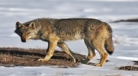 | Orgatiall __________  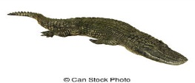
Sroeh ___________  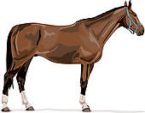 | Itbbar ____________  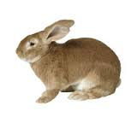

SUBJECTIVE-30
Q No 1:Write 5 living and 5 non-living things. 10
Living things | Non Living thing

Q No2:Write down 2 birds that live in nests . 2

_______________ , _______________

Q No3:Write down 3 animals that eat grains. 3

_______________ , ________________

Q No4:Write down 5 healthy habits of healthy people. 5

_______________, _______________ , _______________,

_______________, _______________

Q No5:Circle 5 healthy foods. 5

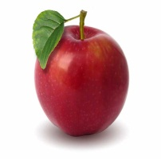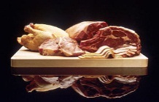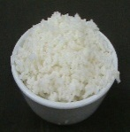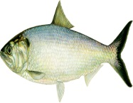

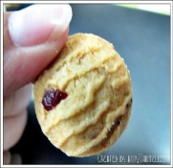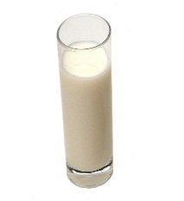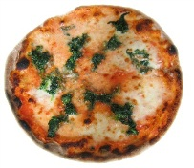

Q No6:Write the of five human senses. 5

________________ , __________________

________________ , __________________

________________

