AFSS CENTRAL EVALUATION SYSTEM
Central Assessment Team (CAT), HO Islamabad
1st Term Examination 2016 – 17

S. STUDIES - Class II
50 marks 2 hours

INFORMATION FOR STUDENTS
Marks are given against each question or part of question.
Write your name, roll number and date in the spaces provided below.
Student’s Name: | Roll No:
Center’s Name: | Date:
 | Day:
Invigilator’s Name: | Sign:
Marks Obtained: | Remarks:
Examiner’sName:  Date: | Sign :  Day:

OBJECTIVE-20

Q No 1:Write one sentence to say what each object is used for. 6
- 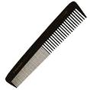 _________________________________________

- 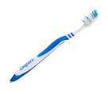_________________________________________

- _________________________________________

Q No 2:Signs are used to warn us of danger.Here are few. Do you know what they mean? 6
- 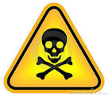________________________________________________________
- 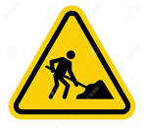_________________________________________________________
- ___________________________________________________________

Q No 3:Can you name some different kinds of fabric? 4
- ________________ 2.__________________
3._________________ 4.__________________

Q No 4:Write the names of two brands of: 4
- Shampoo_____________________________
_____________________________________

- Washing powder_______________________
_____________________________________

SUBJECTIVE-30

Q No 1:Answer any five of the following questions. 5x4 = 20
- Where does wool come from?
- Why do we need food?
- Why are bare electric wires dangerous?
- What do you do to keep your school clean?
- How do rules help us?
- Where do we get our food from?

Q No 2:Answer the following questions. 10

- Why does a soldier or a policeman need special clothes?
_____________________________________________________________
- Why does a doctor wear a white coat?
_____________________________________________________________
- Write two things which make you happy.
_____________________________________________________________
- Write down two things which make you sad.
_____________________________________________________________

