AFSS CENTRAL EVALUATION SYSTEM
Central Assessment Team (CAT), HO Islamabad
1st Term Examination 2016 –17

S. STUDIES - Class I
50 marks 2 hours

INFORMATION FOR STUDENTS
Marks are given against each question or part of question.
Write your name, roll number and date in the spaces provided below.
Student’s Name: | Roll No:
Center’s Name: | Date:
 | Day:
Invigilator’s Name: | Sign:
Marks Obtained: | Remarks:
Examiner’sName:  Date: | Sign :  Day:

OBJECTIVE-20(marks)

Q No. 1:Name four things that you enjoy doing in schools. 4

i) ____________________________________________.
ii) ____________________________________________.
iii) ____________________________________________.
iv) ____________________________________________. Q No.2:We use these materials to build houses.Write the correct number in the boxes. 5
- Cement 2. Bricks 3.Wood 4. Steel 5. Sand 6.Tiles
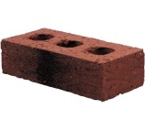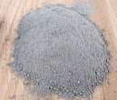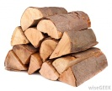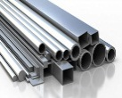

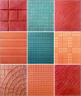

Q No 3:Fill in the missing letter. 5
V __ ___ t Fr__ c__ Jack__ __
Sk ___ ___ t Trou ___e ____s S ___c ___s
Q No 2:Fill in the blanks according the pictures. 6
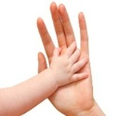
a):This is my ____________

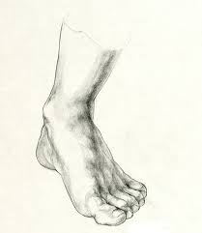
b):This is my___________

c):This is sara.
She has ______________ hair.
Her eyes are ______________.

d): This is Jim.
He has ______________hair.
His eyes are _______________.

SUBJECTIVE-30(marks)

Q No 1:Answer any four of the following questions. 5 x 4 = 20
- What is the name of your school?
- How many rooms are there in your house?
- Which fruits do you like the best?
- What things do you do to keep clean?
- What parts of your body do you use for running?
Q No 2:Write the names of 10 body parts. 10
________________ ________________

________________ ________________

________________ ________________

________________ ________________

________________ ________________

