AFSS CENTRAL EVALUATION SYSTEM
Central Assessment Team (CAT), HO Islamabad
1st Term Examination 2016 – 17

MATHEMATICS - Class I
50 marks 2 hours
INFORMATION FOR STUDENTS
Marks are given against each question or part of question.
Write your name, roll number and date in the spaces provided below.
Student’s Name: | Roll No:
Center’s Name: | Date:
 | Day:
Invigilator’s Name: | Sign:
Marks Obtained: | Remarks:
Examiner’s Name:  Date: | Sign :  Day:

OBJECTIVE-20(marks)

Q No1(a):Fill in the numbers and number names. 10
i) 20 + 2 ______ _______
27
ii) _______ 27 _______
Fill ‘>’ or ‘<’ in the empty boxes.
iii) 50 20
iv) 60 70
What does the abacus show? Write in the empty boxes.
v) (vi)

Q No2:Some numbers are missing find and write them. 5

27
47
17_______ ______ _____ _____ _____

77_______ ______ ______-

b) Write bigger and smaller. 2

_______ ______

c) Colour the third, eighth, and tenth vessels. 3

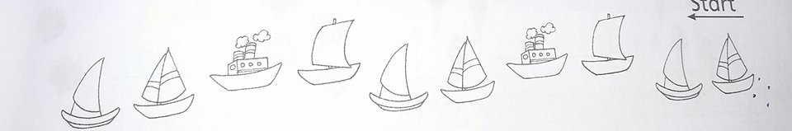

SUBJECTIVE – 30(marks)

Solve the following question. Each question carries equal marks. 3x10=30
Q No1:Find the groups of 10, then add.

- 3
- 6
+ 9 + 4

Q No2(a):There are 14 children in a team, 8 of them are boys. How many girls are there in the team?

Q No2(b):Subtract the following
1 2

- 0 5

Q No3(a):Write in tens and ones.

30 tens + Ones

(b):How many tens in given number?

90

(c):Start with 5, count and write in tens.
5 | r15

