AFSS CENTRAL EVALUATION SYSTEM
Central Assessment Team (CAT), HO Islamabad
1st Term Examination 2016 – 17

COMPUTER - Class II
50 marks 2 hours

INFORMATION FOR STUDENTS
Marks are given against each question or part of question.
Write your name, roll number and date in the spaces provided below.
Student Name: | Roll No:
Center Name: | Date:
 | Day:
Invigilator Name: | Sign:
Marks Obtained: | Remarks:
Examiner Name:  Date: | Sign :  Day:

OBJECTIVE-20(marks)
Q No 1: Tick () the correct and cross (x) the wrong ones. 5
- Mouse helps you to type letters. __________
- CD is put inside a CD drive. __________
- UPS is the brain of the computer. __________
- Monitor looks like a TV screen. __________
- Keyboard has no number keys. __________
Q No 2: Fill in the blanks. 5

i) __________ helps you in listening to music.
ii) A computer thinks with its ____________.
iii) A computer does not make ________________.
iv) Computer is very ________________ in doing calculation.
v) A _____________is a pointing device.
Q No 3. Choose the correct word and write it in the space provided. 5

i) A _____________ is pointing device.
a) Mouse b) House c) CD
ii) ______________prints your work on a paper.
- UPS b) Printer c) Monitor
iii) _____________is the brain of a computer.
- CPU b) CUP c) UPS
iv) ____________ helps you to listen to music.
a) Telephone b) Headphone c) Monitor
v) Helps to keep the computer ON when there is no electricity:
a) CPU b) UPS c) Monitor
Q No 4: Match the following. 5

Monitor | 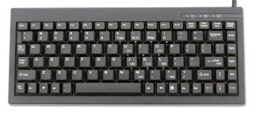
Keyboard
Speaker
Floppy Disk | 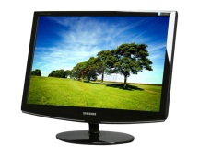
CD | 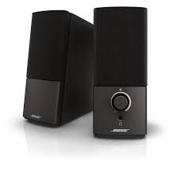

SUBJECTIVE-30

Q No 1: Answer the following questions. Any five 3x5=15
1) Name the device used to take printouts.
2) What is a computer?
3) Write two differences between a computer and a human being.
4) Name two activities that you like to do the most on computers.
5) Which device thinks for the computer?
6) Name the pointing device which shows the arrow on the screen.

Q No 2: Define the following. 6
1) CPU 2) Keyboard 3) Printer

Q No 3: Name parts of a computer. 5
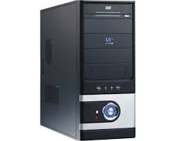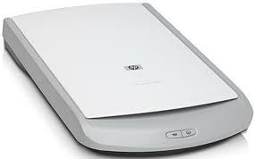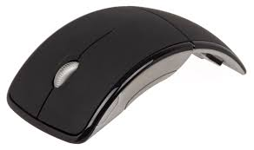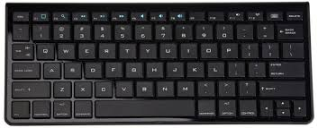
a. ____________________ b. ____________________
c. ____________________ d. ____________________
e. ____________________

Q. 4: Arrange the jumbled words. 4
1) ALTPOP ________________________
2) DSTEKOP _______________________
3) PCOUMETR ______________________
4) PUC ______________________

