AFSS CENTRAL EVALUATION SYSTEM
Central Assessment Team (CAT), HO Islamabad
1st Term Examination 2016 – 17

COMPUTER - Class I
50 marks 2 hours

INFORMATION FOR STUDENTS
Marks are given against each question or part of question.
Write your name, roll number and date in the spaces provided below.
Student Name: | Roll No:
Center Name: | Date:
 | Day:
Invigilator Name: | Sign:
Marks Obtained: | Remarks:
Examiner Name:  Date: | Sign :  Day:

OBJECTIVE-20(marks)

Q No1:Write the correct word and in the space provided. 5
i) _____________ is the brain of computer.
a) Monitor b) CPU c) Mouse
ii) Keyboard has small buttons called ______________.
- Keys b) Kites c) Knees
iii) _________ is used to watch cartoons.
- AC b) TV c) Cooler
iv) A __________ keeps your food and water cool.
- Washing machine b) train c) refrigerator
v) _____________ is used to print things on a computer.
a) Mat b) Monitor c) Mouse

Q No 2:Tick () the correct and cross () the wrong ones. 5
i) Keyboard looks like a TV screen. ______
ii) Cat is the brain of a computer. ______
iii) Mobile phone is a machine. ______
iv) Mouse helps to draw. ______
v) CPU is not an important part of a computer. _______
Q No 3: Fill in the blanks. 5
natural
sums
Man-made
games
music

- Machines are ___________ things.
- We can solve ___________ on a computer.
- Sun, moon, stars are __________ things.
- We can play ____________ on a computer.
- We can listen ___________ on a computer.
Q No 4: Fill in the missing letter. 5

C___ ___ P____T_____R | 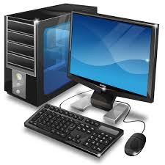
M___C____I_____E | 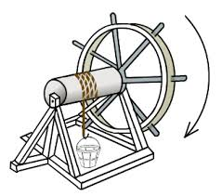
M_____ _____N | 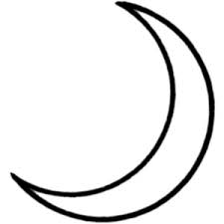
M_____B_____L_______ | 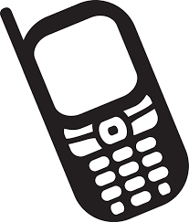
F____U____T

SUBJECTIVE-30(marks)

Q No 1:Answer the following questions. 4x5=20
i) Name the four parts of the computer.
ii) Name 4 things that a computer helps us to do?
iii) Name 4 machines that you see at your home.
iv) Which part of a computer helps to point things on the monitor?
v) Which part of a computer is like a TV?

Q No 2:Put the following words under the correct heading. 10
Sun, Mobile , Moon, Stars, Trees, Rivers, Washing Machine, Microwave,
Animals , Laptop.

Man-made Things |  | Natural Things

